Website mockup

Table des matières

Actual website : 2

Important features : 2

Home page 6

First visual upon arriving on the site 6

The 3 offers: 7

Lounge spa 7

Lounge Receptions 8

Lounge Business 9

Lounge Spa 9

Lounge spa day offer: 9

Home screen of day spa offers 9

Name of the offer 1 : “Se resourcer à deux” 9

Name of the offer 2 : Last minute 17

Lounge spa overnight offer: 21

Home screen of overnight spa offers. 21

Name of the offer 1 : A romantic night 22

Name of the offer 2 : Last minute 24

Lounge Receptions 26

Lounge Receptions offer: 26

Home screen of Lounge Receptions offers 26

Name of the offer 1 : EVJF 27

Name of the offer 2 : Birthdays: 33

Name of the offer 3 : Wedding, engagement, wedding anniversary… 36

Name of the offer 4 : Weekend with Friends: All Inclusive 38

Name of the offer 5 : Customized Reception 39

Lounge Business 41

Lounge Business Offer: 41

Name of the offer 1 : Corporate Event 42

Name of the offer 2 : Seminar 44

Name of the offer 3 : Meeting 45

Name of the offer 4 : Custom Reception 46

# Actual website :

<https://www.loungespa.fr>

# Important features :

* Being able to add the blur effect on the background when we select offers
* HYPER IMPORTANT CRITERIA : Having a booking calendar linkable with other calendar (gmail, outlook…) and please check tools like Brevo and envato (if we can linked everything together) + we neeed something hyper flexible where we can add button to select number of people etc like I put on the screens (check them carefully)
* I’d like to directly implement the booking of housing of that website (let see if its possible) (its what i called “réserver un chalet aux deux étangs”) :
  + 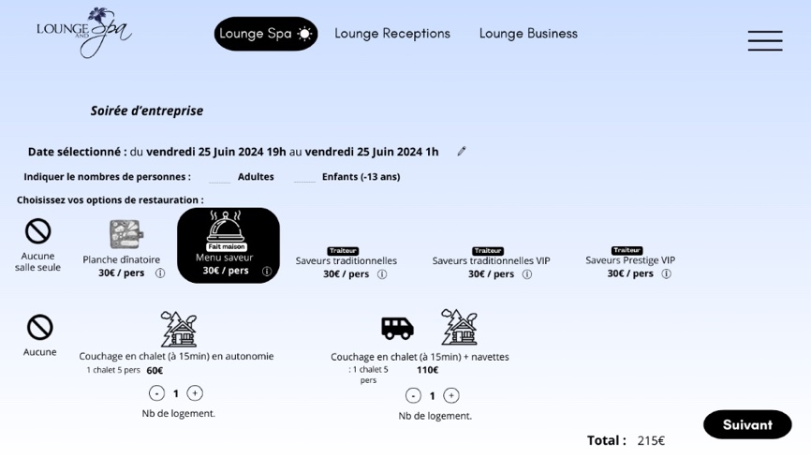
  + There is the website : <https://www.domainelesdeuxetangs.fr>
* Delete the green deal offer for all the offers
* PAY ONLINE
* Beeing responsive and firstly developed for mobile (even if it has to work on computer too)

**Few graphics specifications :**

* This is the “artistic direction” :
  + Luxury and wellness + VIP cosy villa
  + Modern and refined design, colour and font
  + Copy Airbnb (more or less and with our specifications) : <https://www.airbnb.fr>
  + We will implement advertising videos like that on the website : <https://www.youtube.com/watch?v=xhXxfencjHo> => So we have to do a gradient colour background and all the design to fit with that ! (check how the colour of the background evolve in each ads)
  + The best would be that the colour evolve with the content like on Airbnb ads
  + Some ideas and examples for the background : 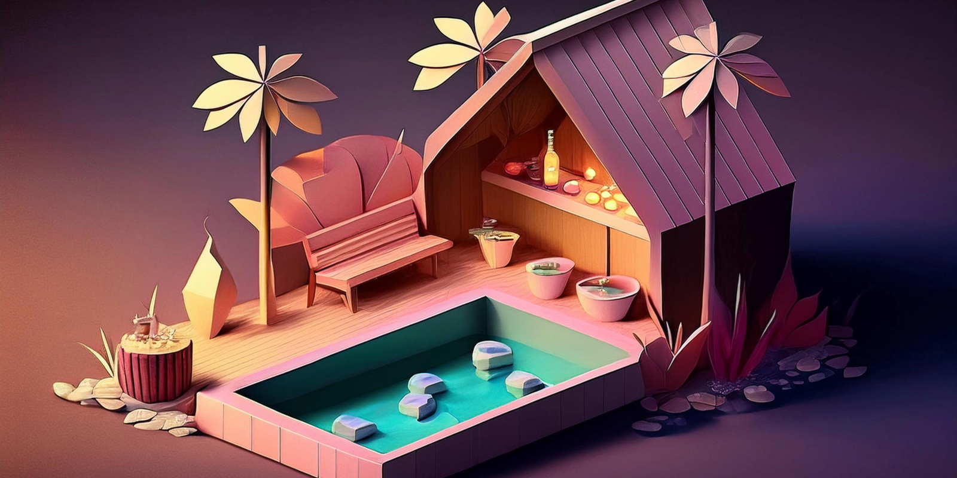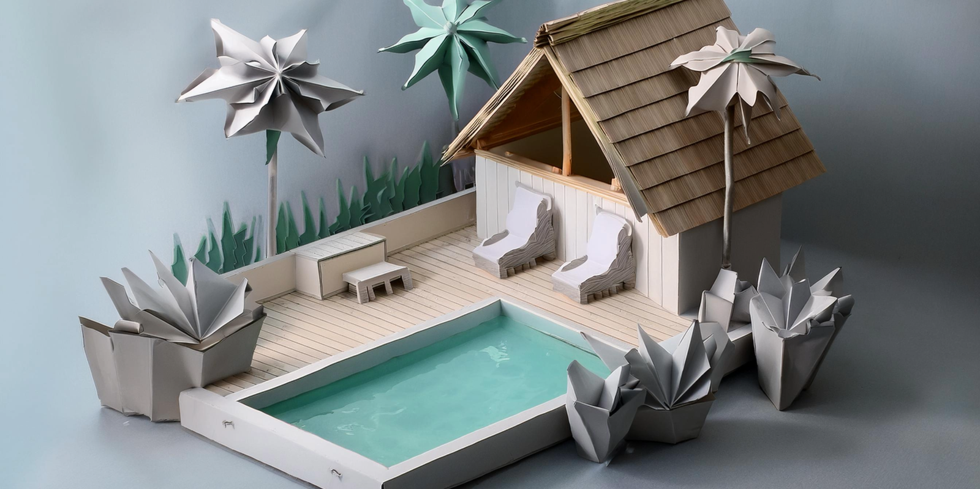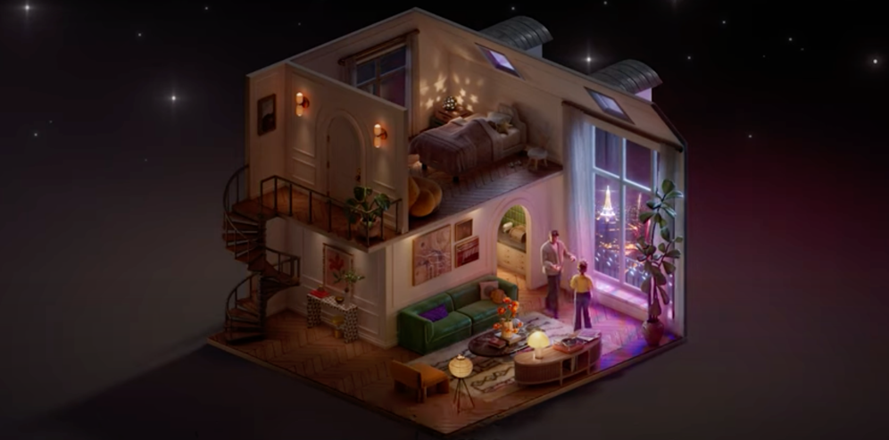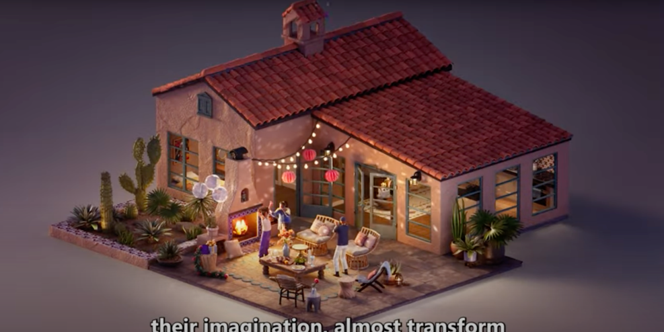

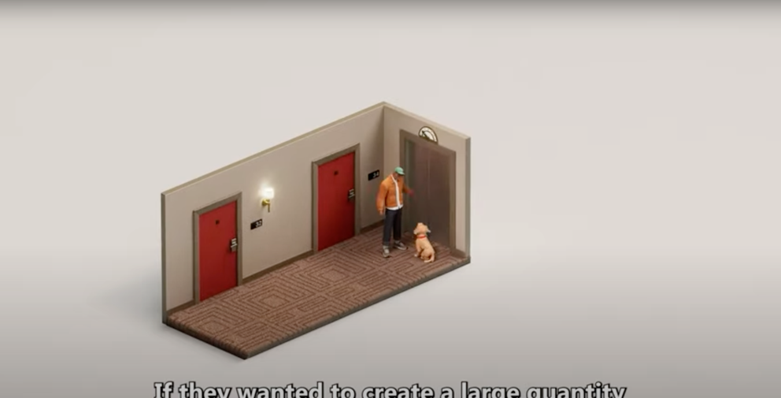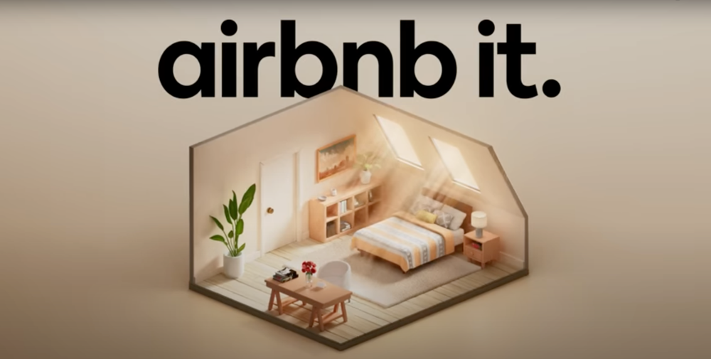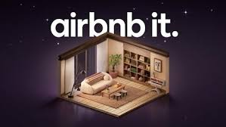

* I’d like that we find a way to implement parallalx between the day and night offer (don’t know how to present that, maybe having it on the samee page and just scroll between day and night, I don’t know… if you can help on that thing…)
  + For me there is 2 option :
    - Scroll on the same page and switch from night to day offer (but it can lost clients and I think that we don’t adopt that kind of organization with that website)
    - Or just when we click on the day we see from night to day and the opposite when we click on the night option => and having the normal background at a moment and for the other offers (let see what we can do)
  + <https://day-night-parallax.netlify.app/> (something a bit more like in the Airbnb advertisement and less childish than this one)
  + Few ideas of background :

# Home page

## First visual upon arriving on the site

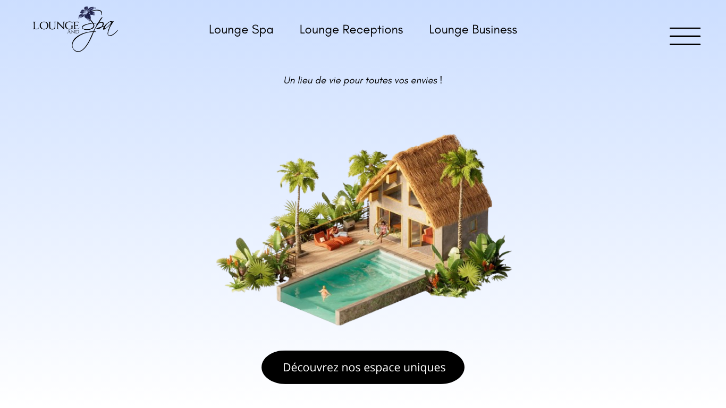

* 3 main types of offers highlighted to facilitate booking
* "Discover" button to quickly view the places (videos + photos)
* Menu button: for other secondary tabs (e.g., about, partners, discover our spaces...)
* "Darkened" logo for better color matching: redirects to the home page when clicked

## The 3 offers:

When clicking or hovering over one of the 3 offers, a dropdown menu appears > the background becomes blurred (see the photo below).

### Lounge spa

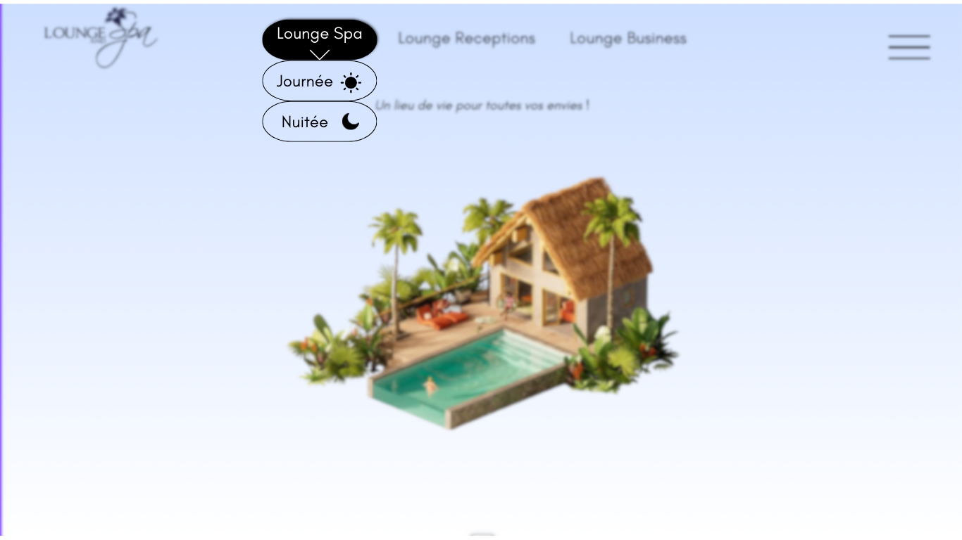

* When clicking or hovering over the Lounge & spa offer: the dropdown menu appears > the rest becomes blurred.

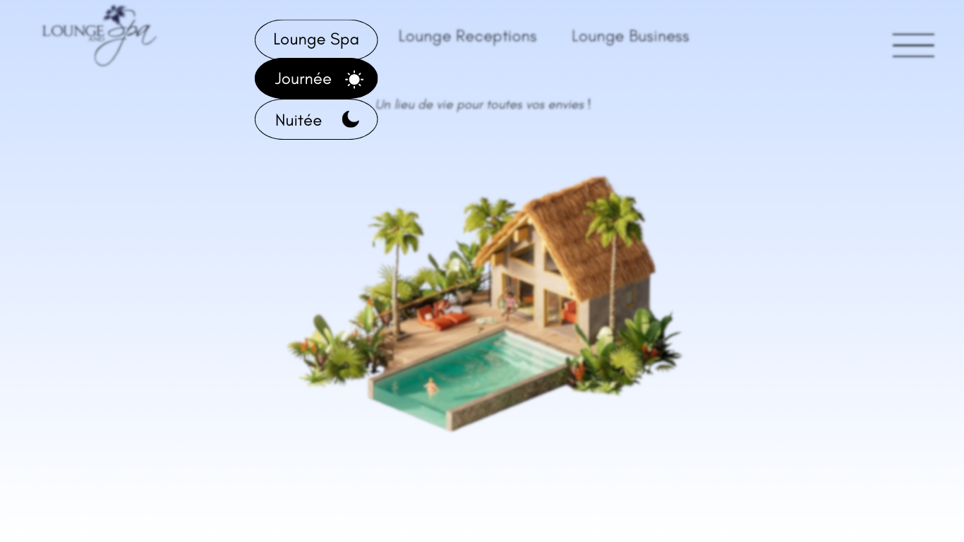

* When hovering over the different menus inside this dropdown menu > they turn black.

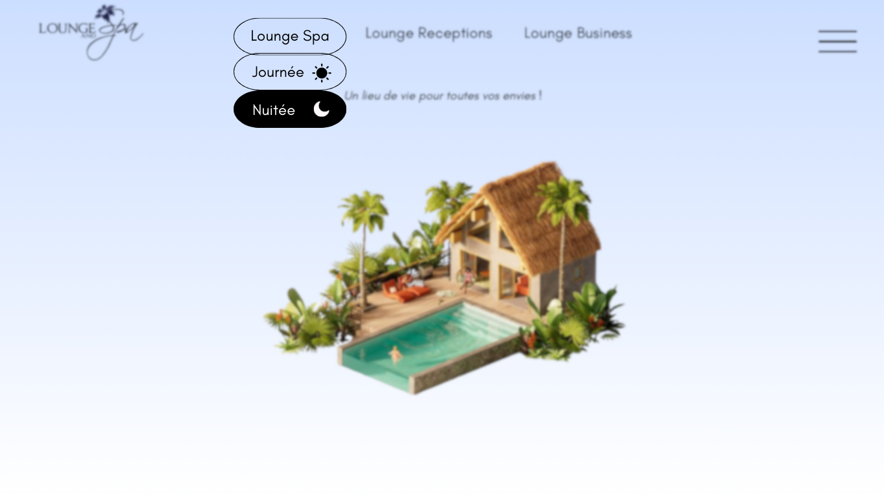

### Lounge Receptions

* When clicking or hovering over the Lounge Receptions offer: the dropdown menu appears > the rest becomes blurred

### Lounge Business

* When clicking or hovering over the Lounge Business offer: the dropdown menu appears > the rest becomes blurred

# Lounge Spa

## Lounge spa day offer:

### Home screen of day spa offers

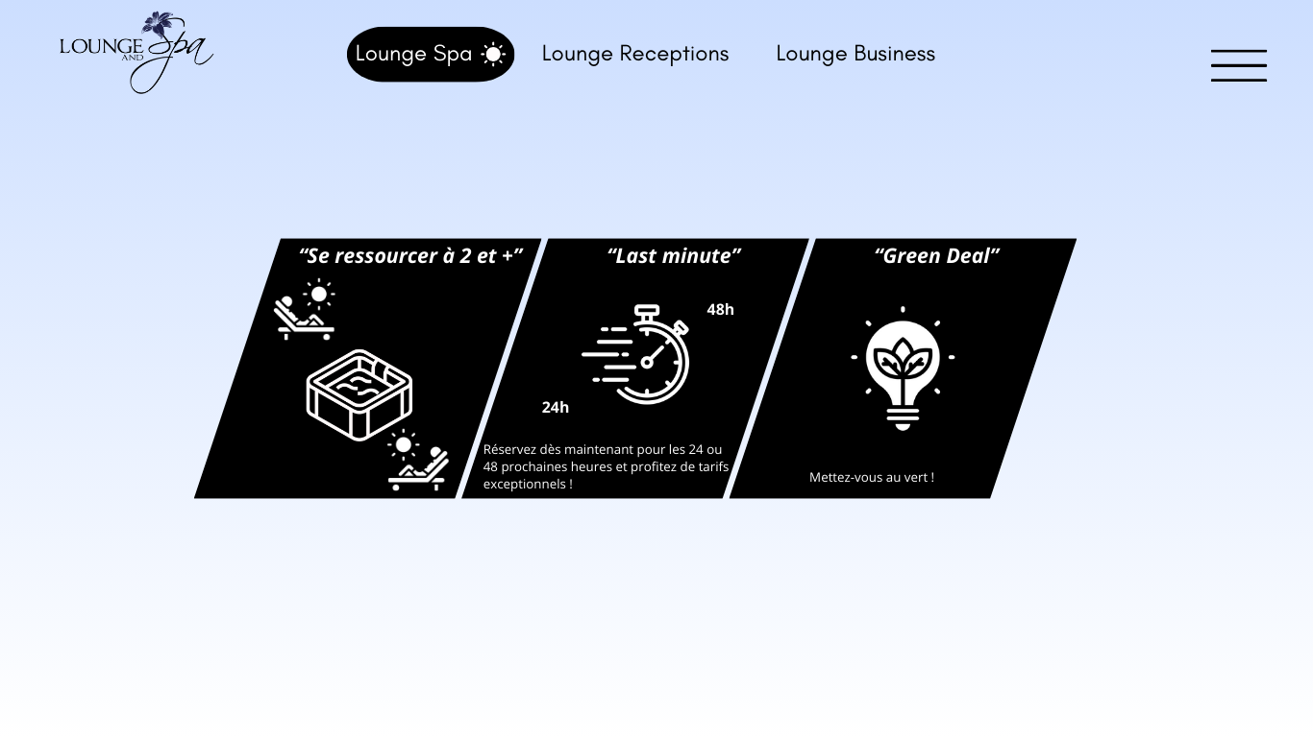

* + The 3 offers are present (keep only 2 as mentioned below)
  + When hovering over one of them, it is highlighted (slightly enlarges, similar to video game menus) compared to the others.
  + Delete the Green deal offer (we will not do it, you can delete it for all the next screens)

### Name of the offer 1 : “Se resourcer à deux”

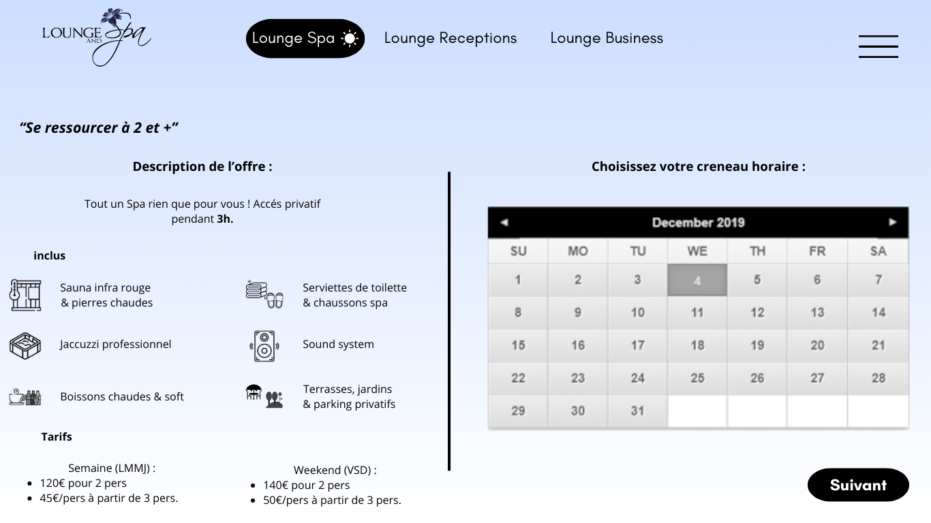

* + This page provides the description of the offer.
  + Pricing for week and weekend (perhaps use something other than bullets to make this section more visually appealing).
  + The calendar should be linked to all bookings: (**need to find a theme adapted to that features)**
  + Change gray boxes to green when available and red or orange (choose what looks best aesthetically and is not too harsh)
  + Do not allow the "Next" button to be clicked if no date is selected
  + Consider displaying the selected dates in full text between the calendar and the "Next" button

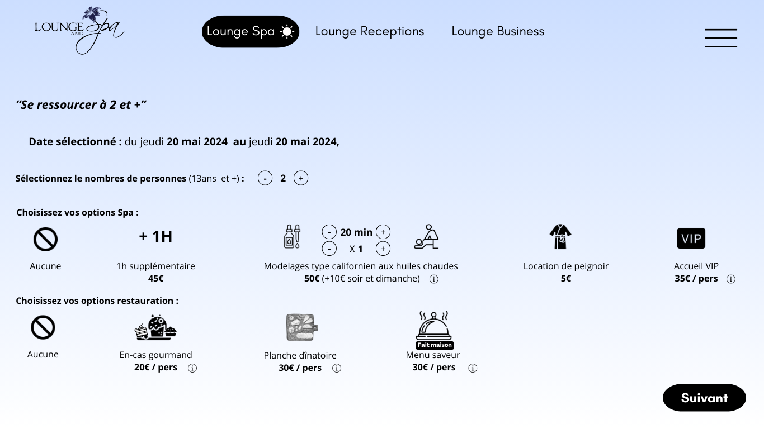

* + Choice of number of people (minimum 2, maximum 12)
  + I have set 13 years and up (copied from Airbnb criteria)
  + Whenever the "Saveur Fait Maison" menu is available, add a small camera icon next to the info point:
* Clicking on it opens a viewer tool showing photos of several "Saveur Fait Maison" menus
  + Enhance the icons if better ideas or more suitable graphics are available

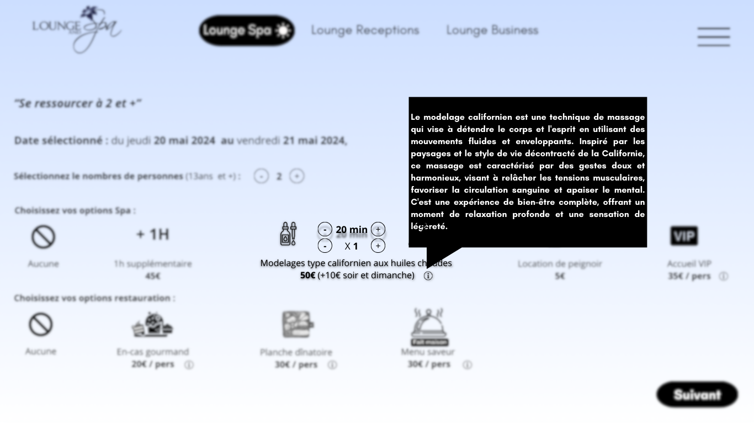

* + When hovering over the small info points: more explanation appears and the rest of the screen becomes blurred (except for the concerned offer).

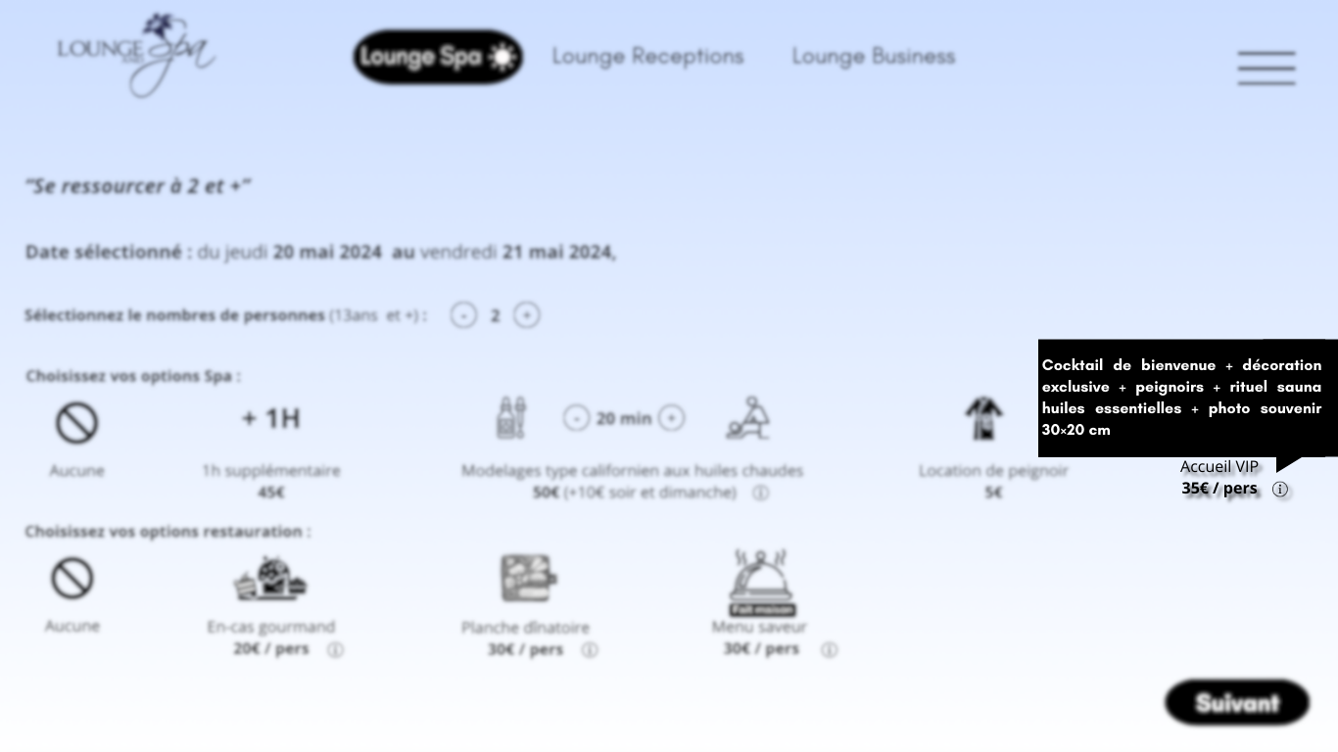

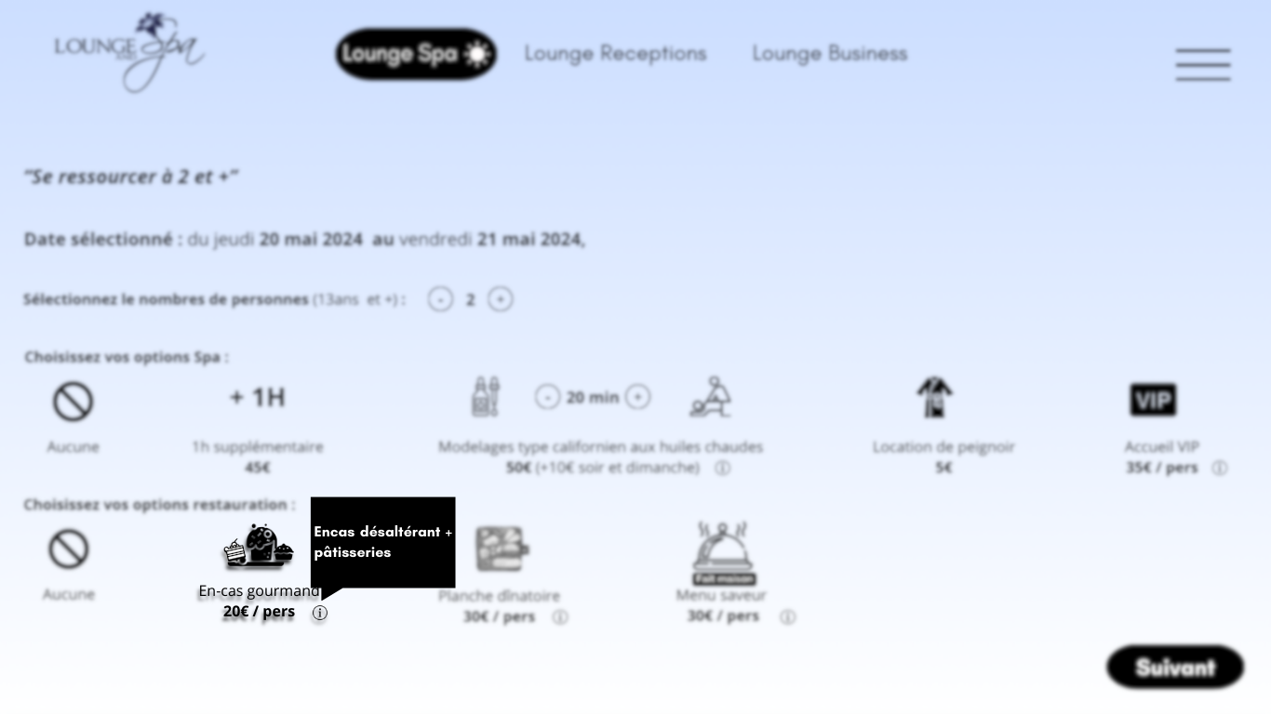

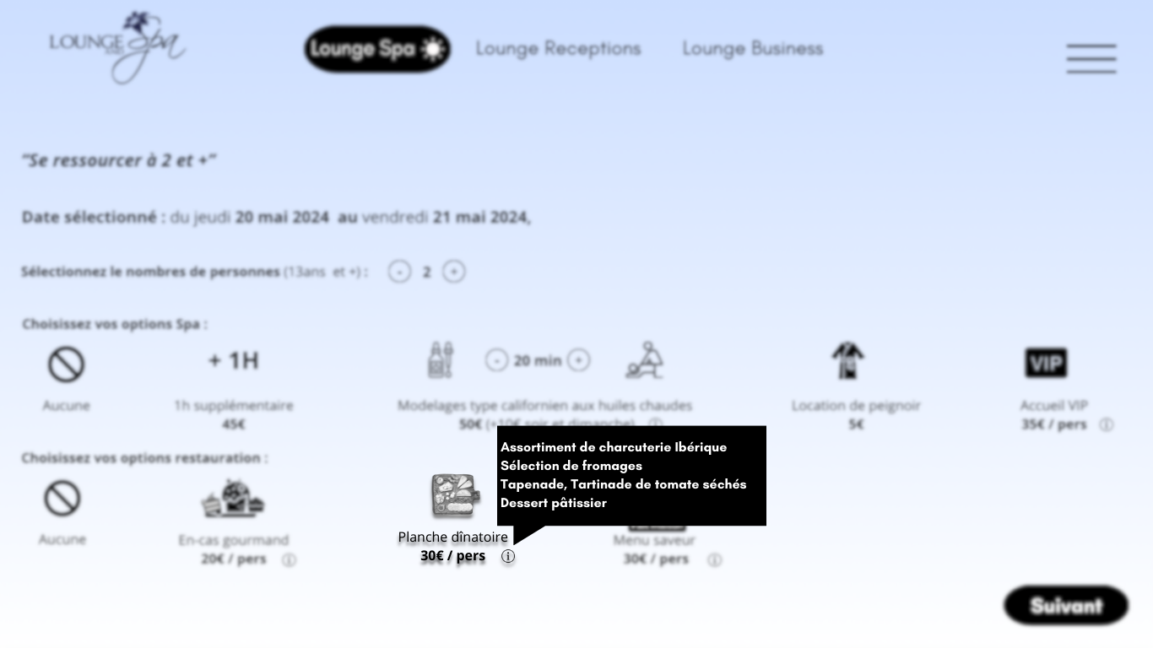

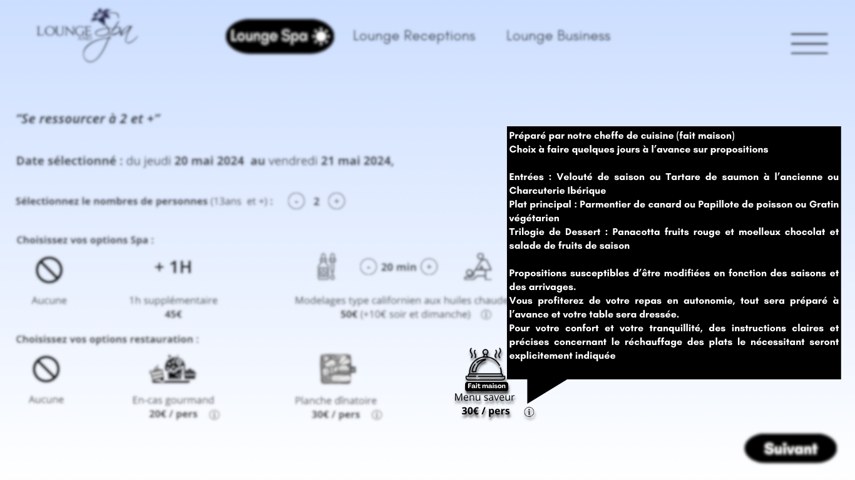

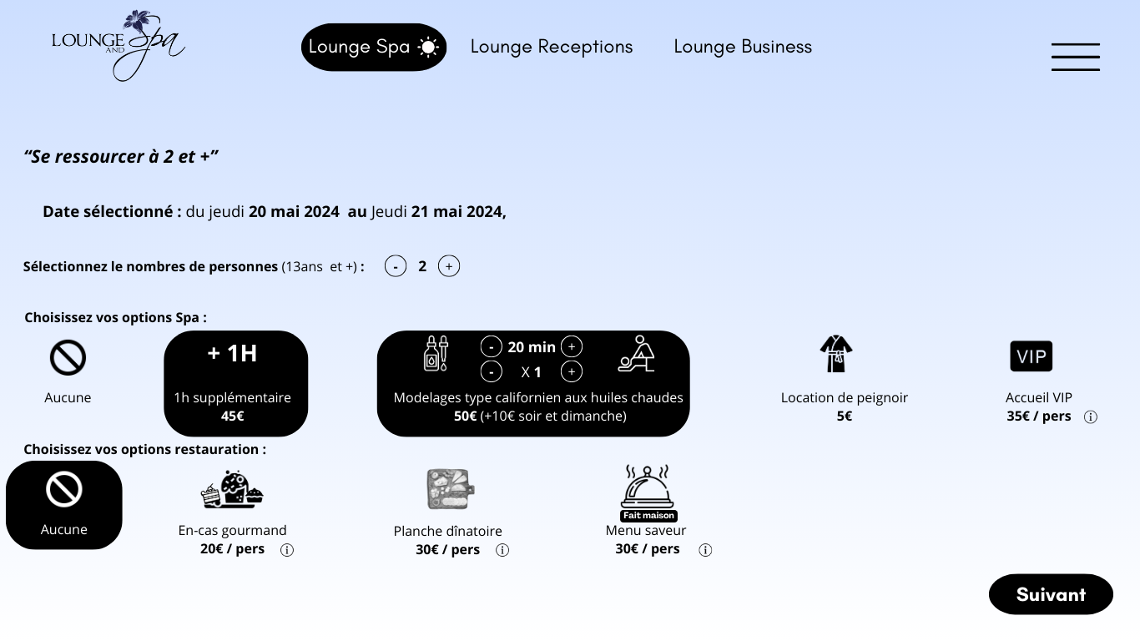

* + When selecting spa and dining options: selection turns black and icons and text change to white
  + Add hours (exact reservation times)
  + When clicking on "None," all selected options are deselected

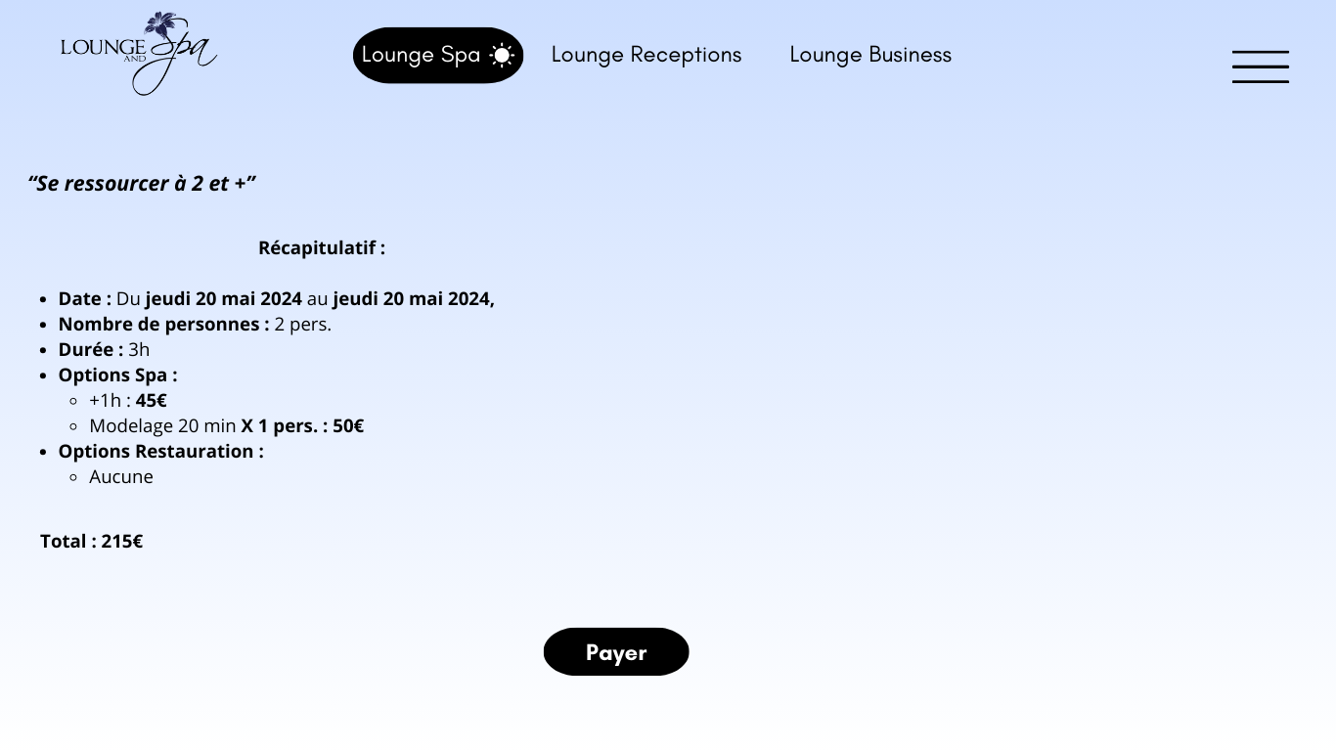

* + After clicking "Next," the summary screen appears.
  + Add the exact reservation times.
  + Improve the graphical section by taking inspiration from summary pages on e-commerce sites like Nike, Amazon, AliExpress, etc.

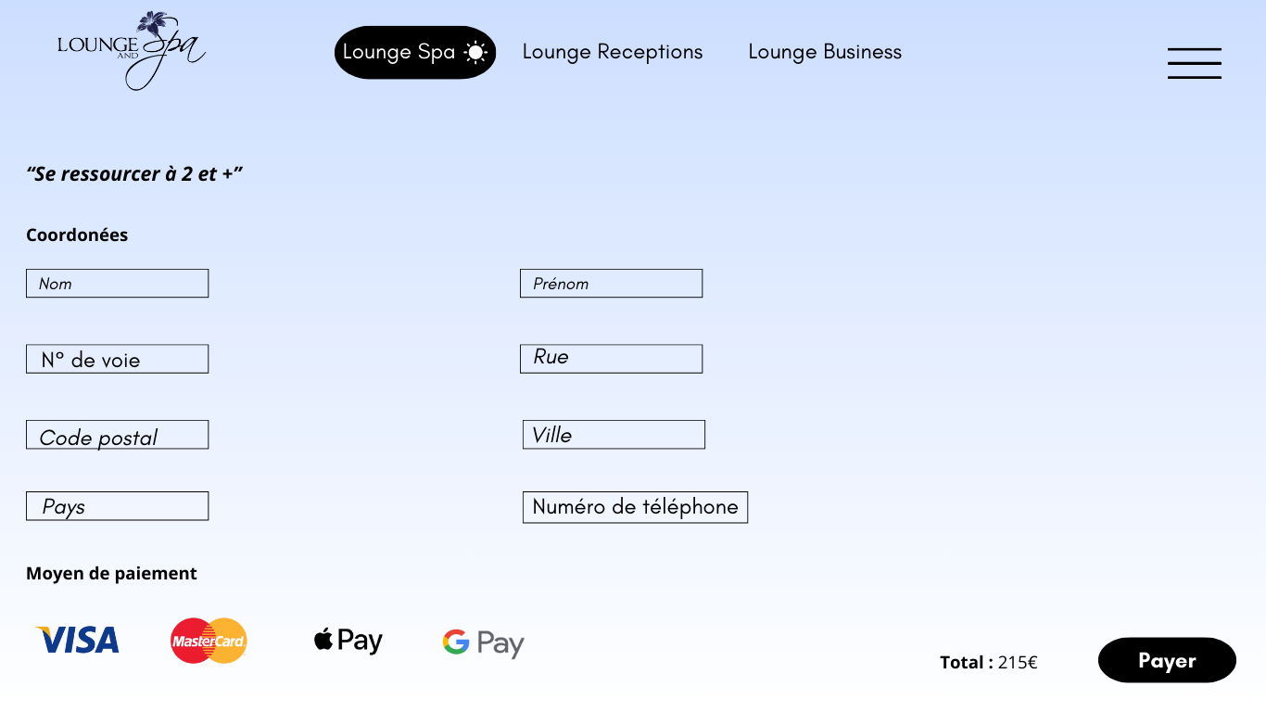

* + The client enters their contact details (All fields are mandatory!).

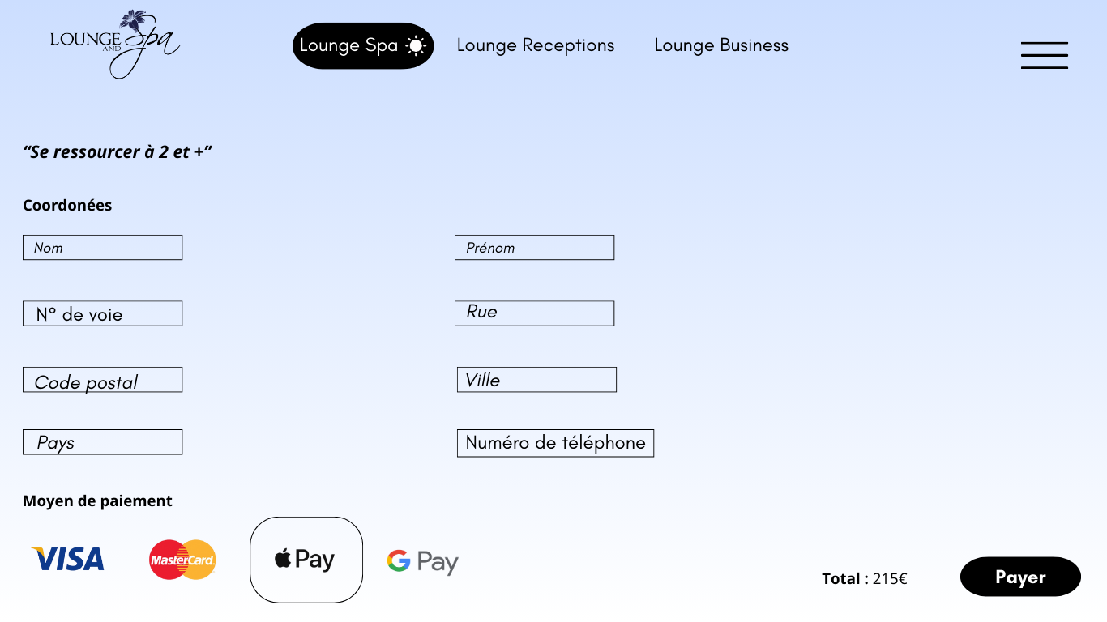

* + The client chooses their payment method.
  + Add PayPal.

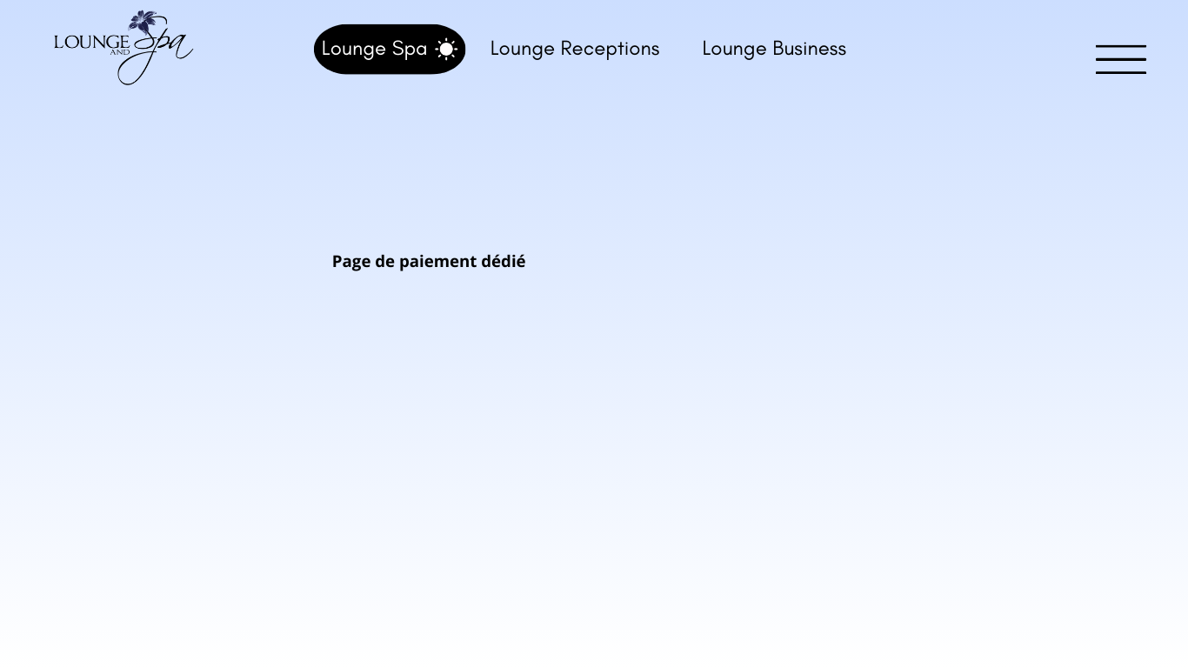

* + Dedicated payment page based on the selected payment method.

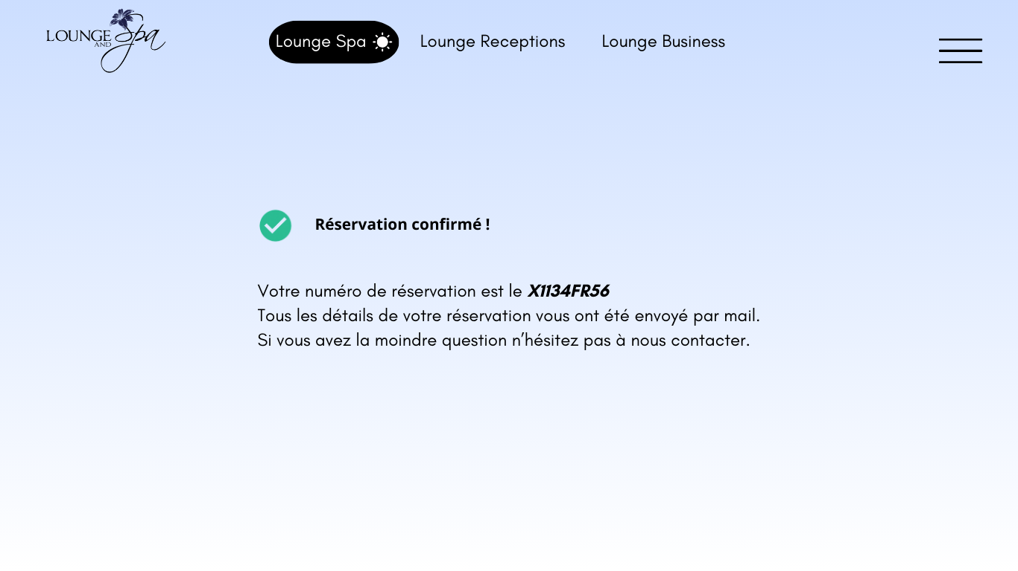

* + Reservation confirmation with the reservation number.
  + Send the summary and invoice by email (define the email template and visuals).

### Name of the offer 2 : Last minute

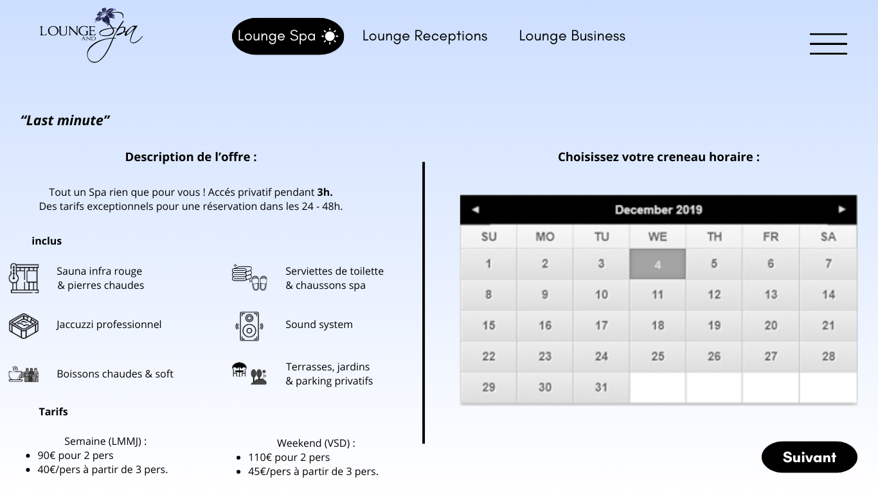

* + This page provides the description of the offer.
  + Pricing for weekdays and weekends (consider using something other than bullets to make this section more visually appealing).
  + The calendar should be linked to all bookings:
    - Change gray boxes to green when available and red or orange (choose what looks best aesthetically and is not too harsh).
    - Do not allow the "Next" button to be clicked if no date is selected.
    - Consider displaying the selected dates in full text between the calendar and the "Next" button.
    -  For this offer, the available booking slot is blocked after 48 hours (adjust according to the current date and time).

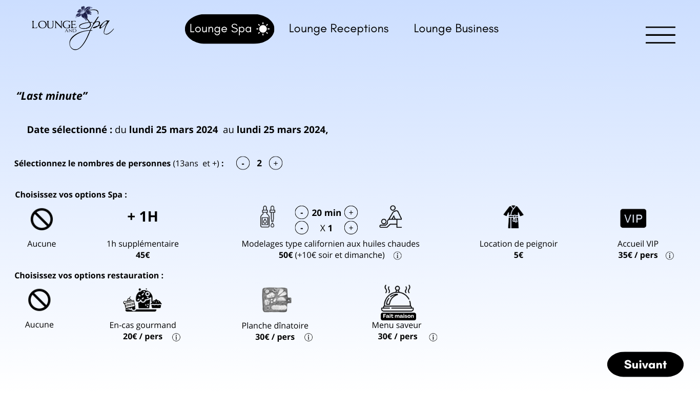

* + Same as the previous offer (with info points).
  + Add the exact reservation times.

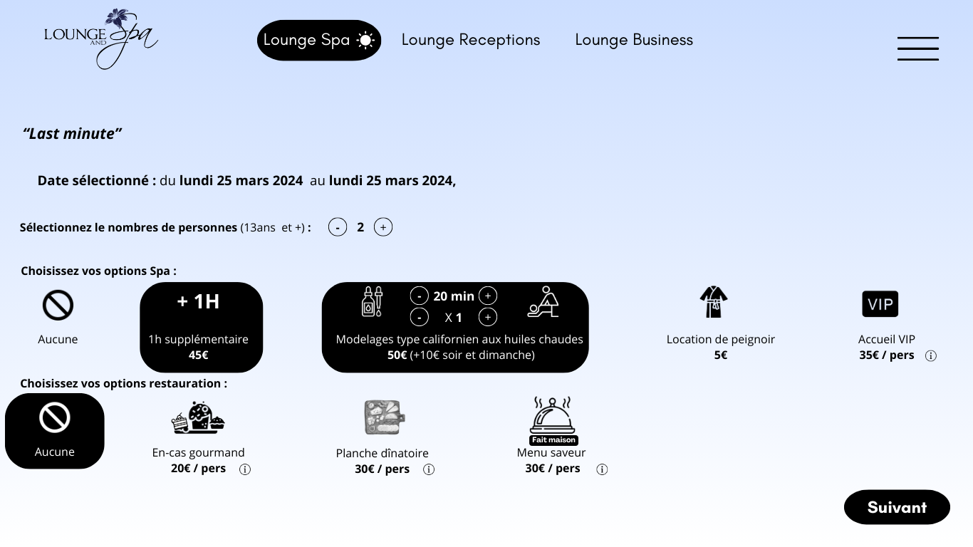

* + Choice of the number of people (minimum 2, maximum 12).
  + Add the exact reservation times.
  + Same as the options for the previous offers.

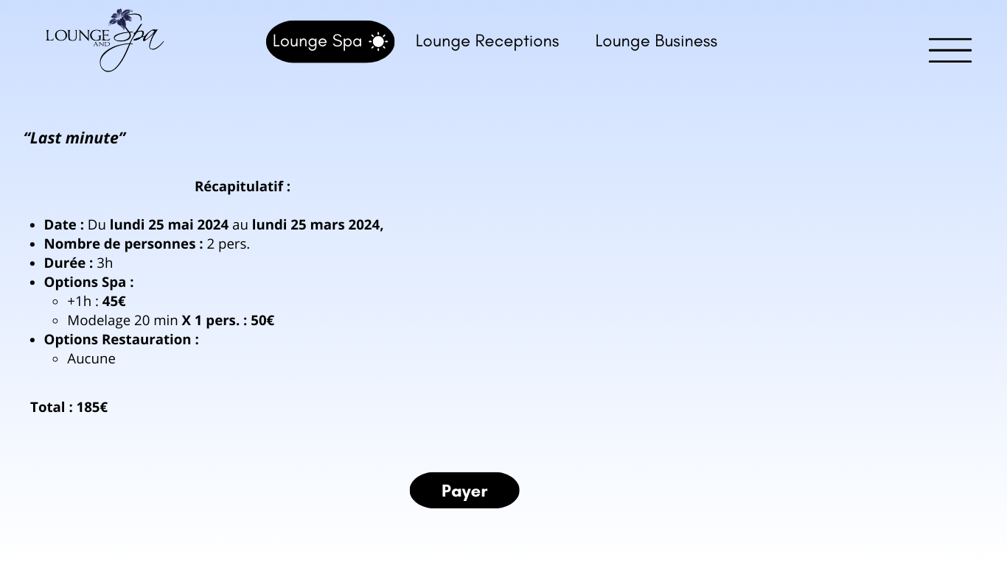

* + After clicking "Next," the summary screen appears.
  + Add the exact reservation times.
  + Enhance the graphical design, taking inspiration from summary pages on e-commerce sites like Nike, Amazon, AliExpress, etc.

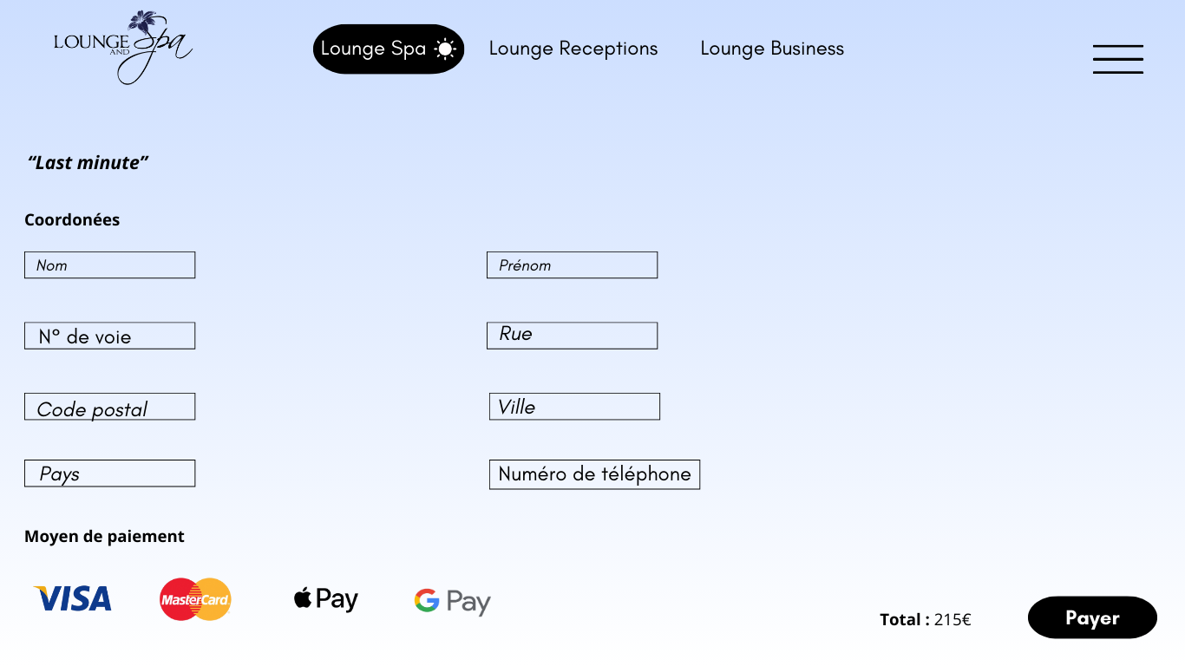

* + The client enters their contact details (All fields are mandatory!).

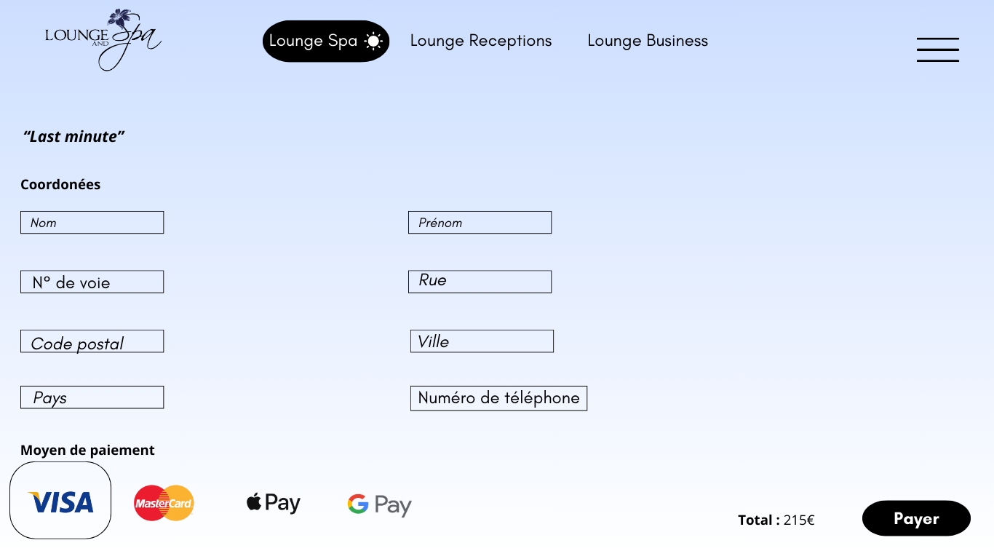

* + The client selects their payment method.

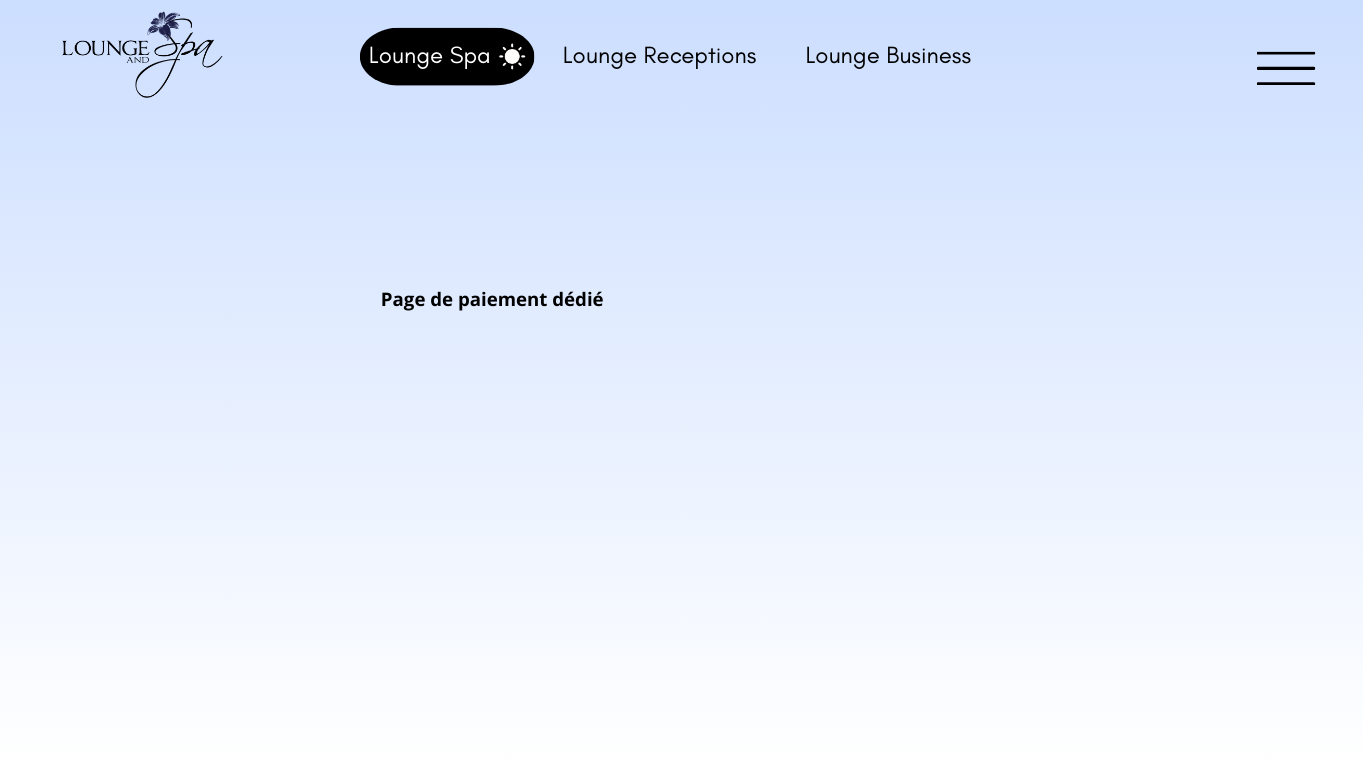

* + Same as for the previous offer.

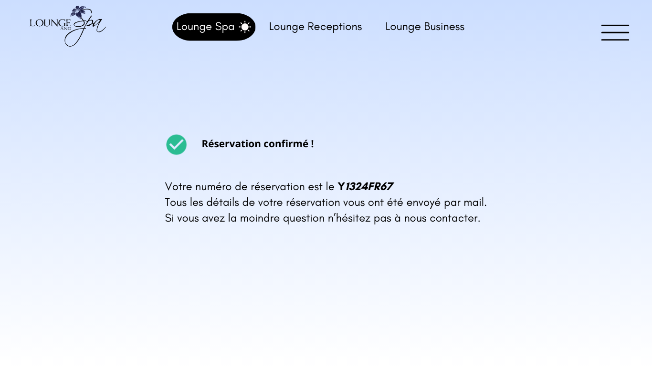

* + Reservation confirmation with the reservation number.
  + Send the summary and invoice by email (define the email template and visuals).

## Lounge spa overnight offer:

### Home screen of overnight spa offers.

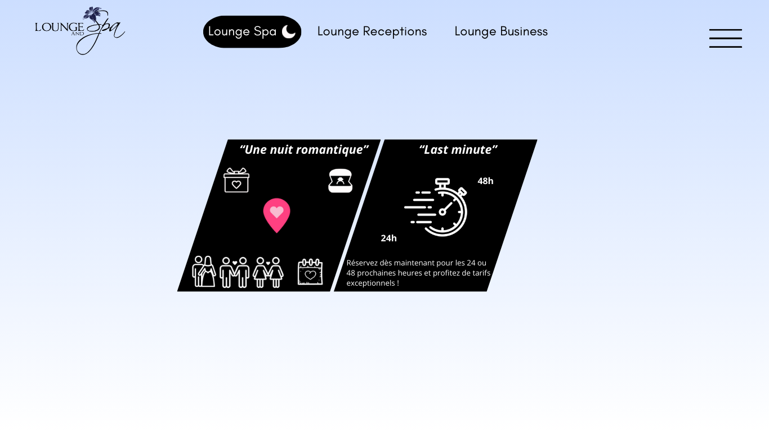

* + The 2 offers are present.
  + When hovering over one of them, it is highlighted (slightly enlarges, like in video game menus) compared to the others.

### Name of the offer 1 : A romantic night

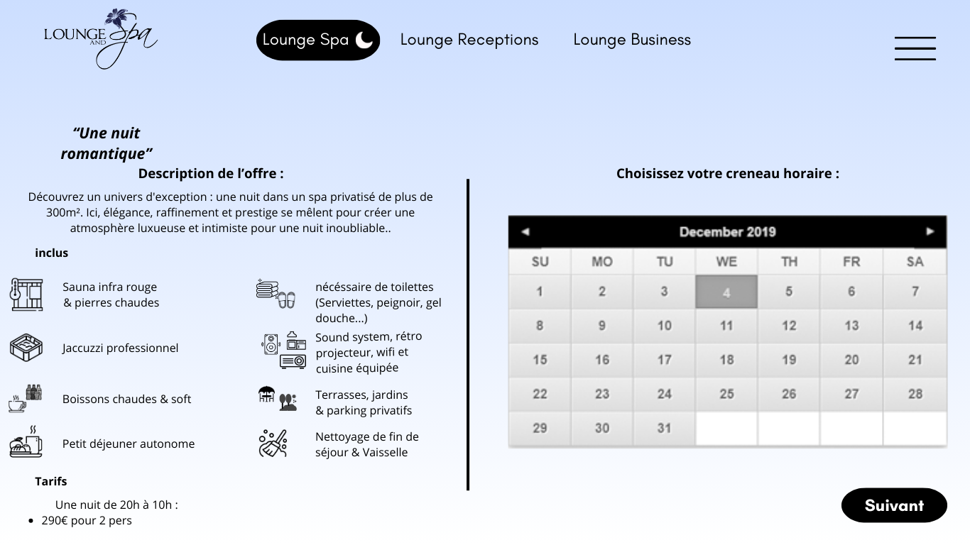

* + This page provides the description of the offer.
  + Pricing (consider using something other than bullet points to make this section more visually appealing).
  + Ensure the offer name is displayed in a line format and not as a block, as shown in the image.
  + The calendar should be linked to all bookings:
    - Change gray boxes to green when available and to red or orange (choose what looks best aesthetically and isn't too harsh).
    - Do not allow the "Next" button to be clicked if no date is selected.
    - Consider displaying the selected dates in full text between the calendar and the "Next" button.

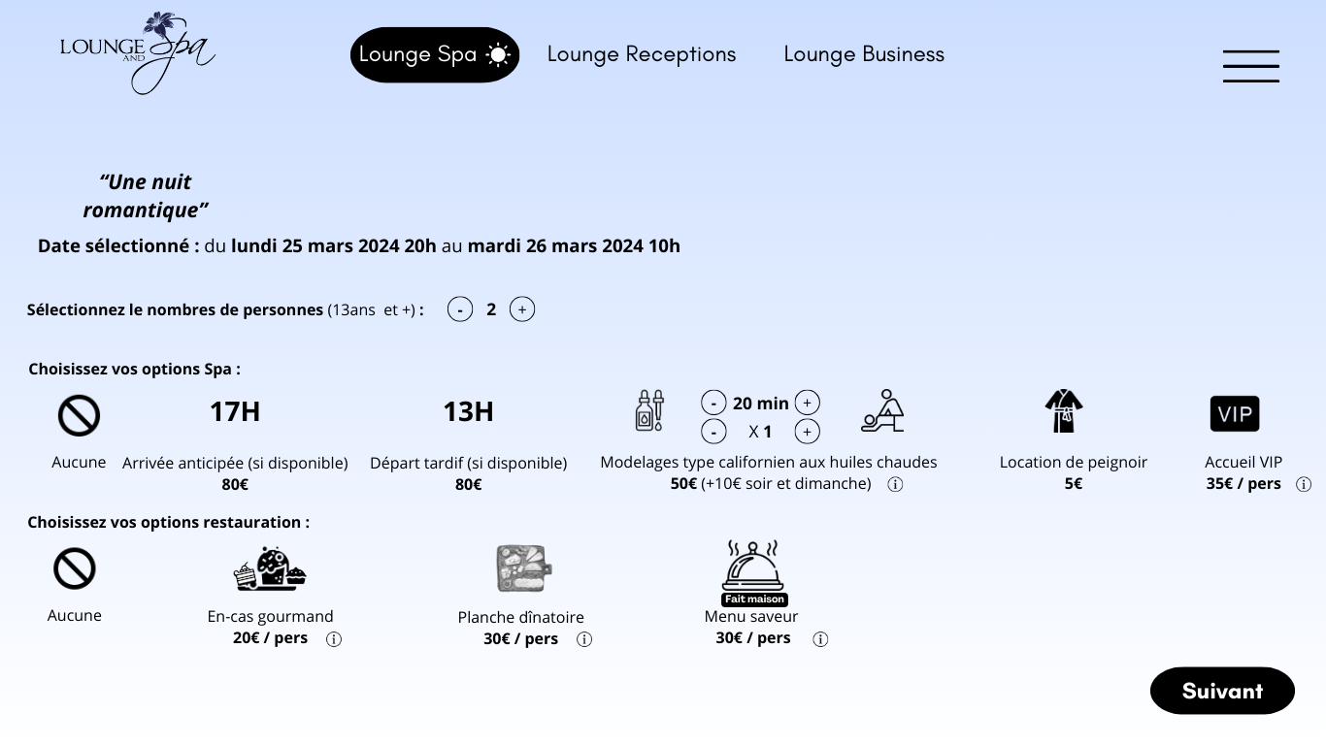

* + Same functionality as for the other offers.
  + Remove the "+" and "-" for selecting the number of people (only 2); simply write "number of people."

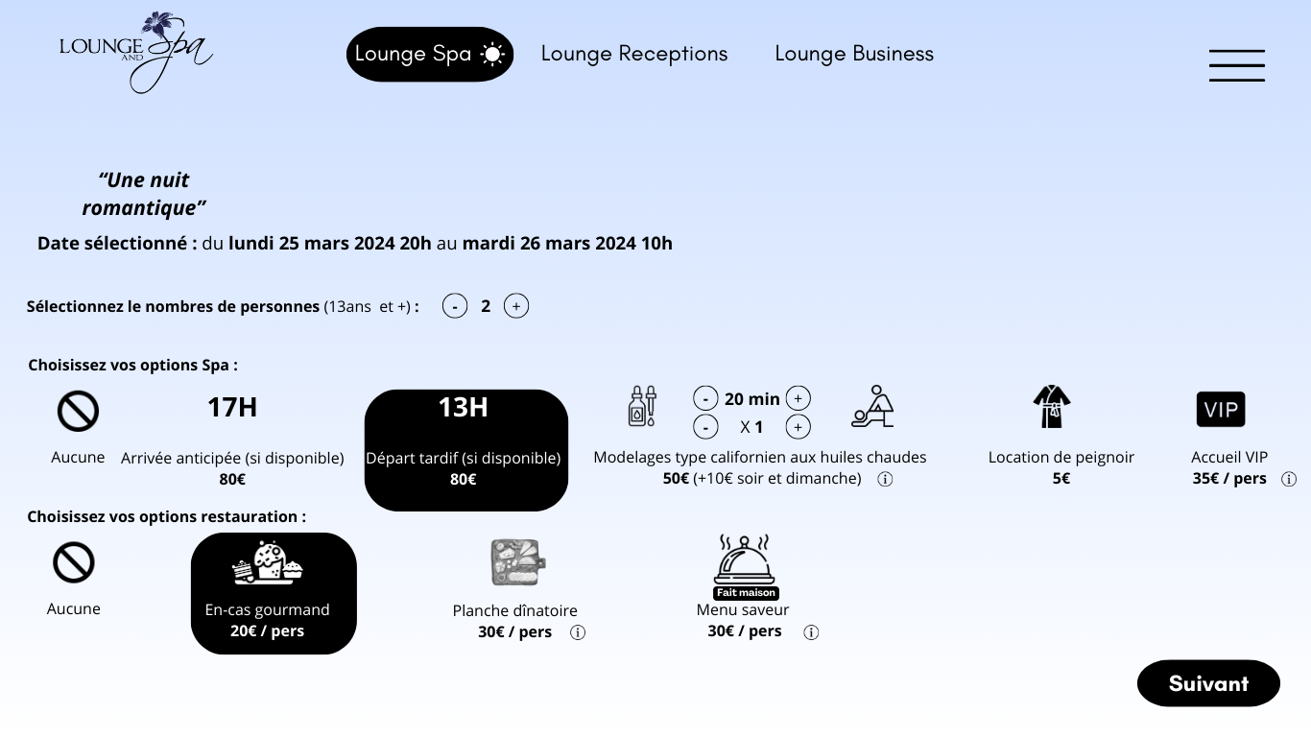

* Selection process as with the other offers.
* The following screens are the same, including the summary, choice of payment method, payment, confirmation, etc.

### Name of the offer 2 : Last minute

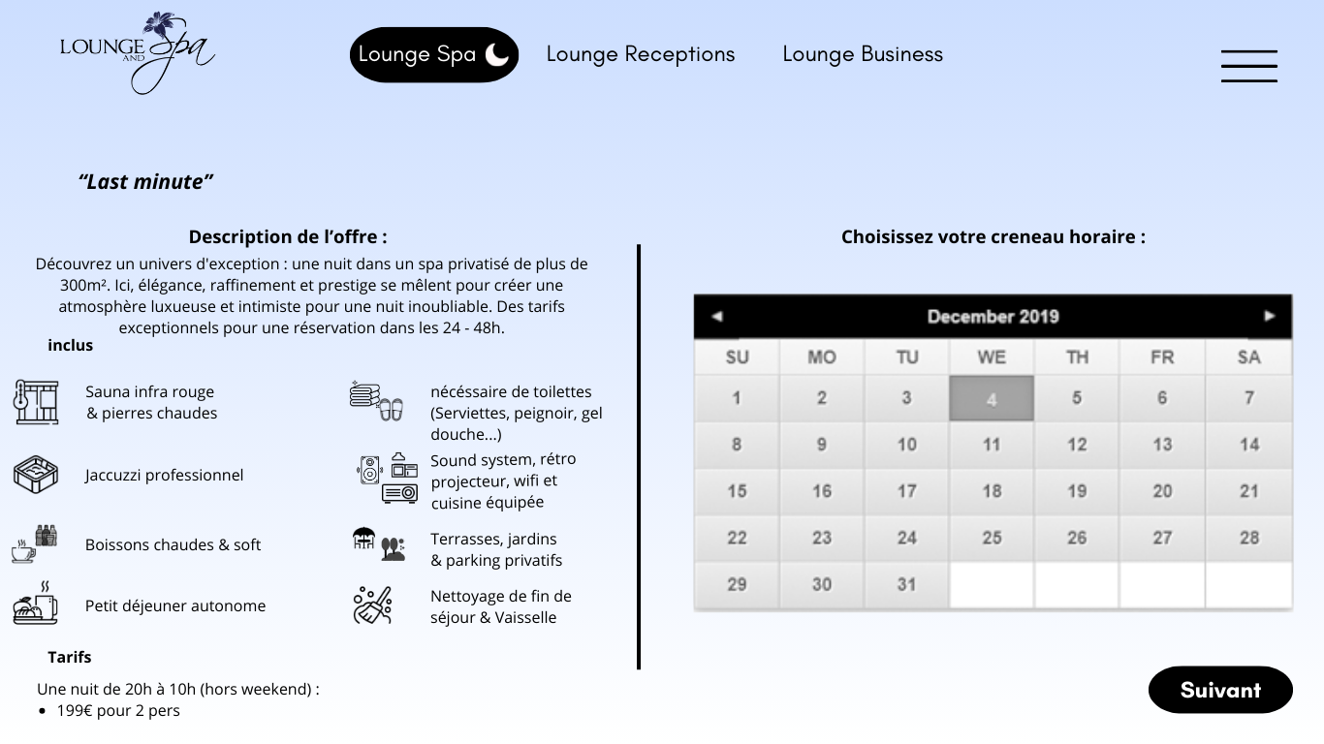

* + This page provides the description of the offer.
  + Pricing: consider using something other than bullet points to make this section more visually appealing.
  + The calendar should be linked to all bookings:
    - Change gray boxes to green when available and to red or orange (choose what looks best aesthetically and isn't too harsh).
    - Do not allow the "Next" button to be clicked if no date is selected.
    - Consider displaying the selected dates in full text between the calendar and the "Next" button, including arrival and departure times.

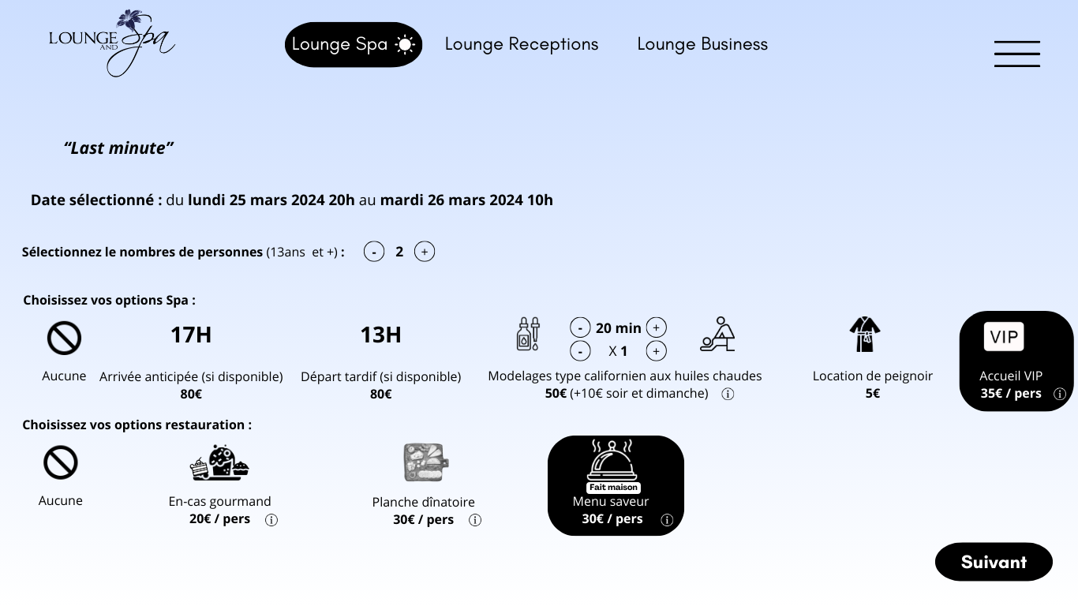

* + Selection process as for the other offers.
  + The following screens are the same, including the summary, choice of payment method, payment, confirmation, etc.

# Lounge Receptions

## Lounge Receptions offer:

### Home screen of Lounge Receptions offers

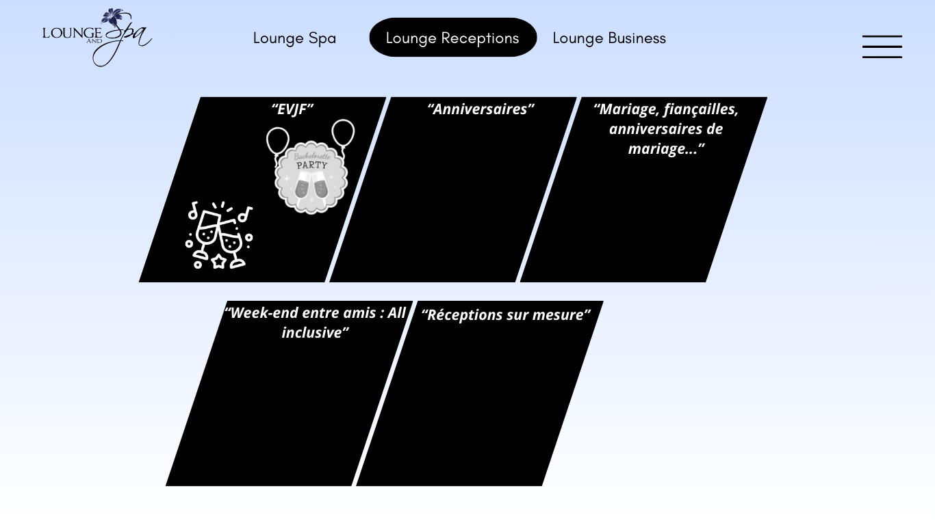

* + Propose new icons (graphics for different offers).
    - Remove the existing icons for EVJF.
  + When hovering over one of the offers, it is highlighted (slightly enlarges, like in video game menus) compared to the others.

### Name of the offer 1 : EVJF

**Home screen of EVJF offers**

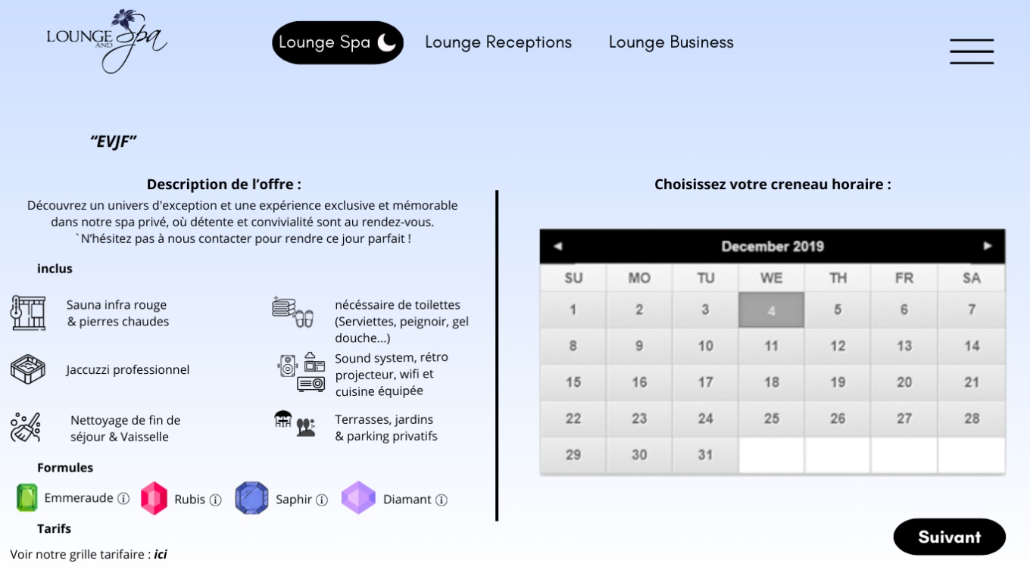

* + Make the small "i" (information) icons bold.
  + Add a small "i" to the sound system section and include three dots after "fully equipped kitchen."
    - In the info section, include: Karaoke, wireless microphone, dance floor, bar (indoor and outdoor).
  + Update the description to: "Discover an exceptional universe through an exclusive and memorable experience in our private spa, where relaxation and friendliness await. Have a special request? Contact us!"
  + Transform the gemstones into black and white.

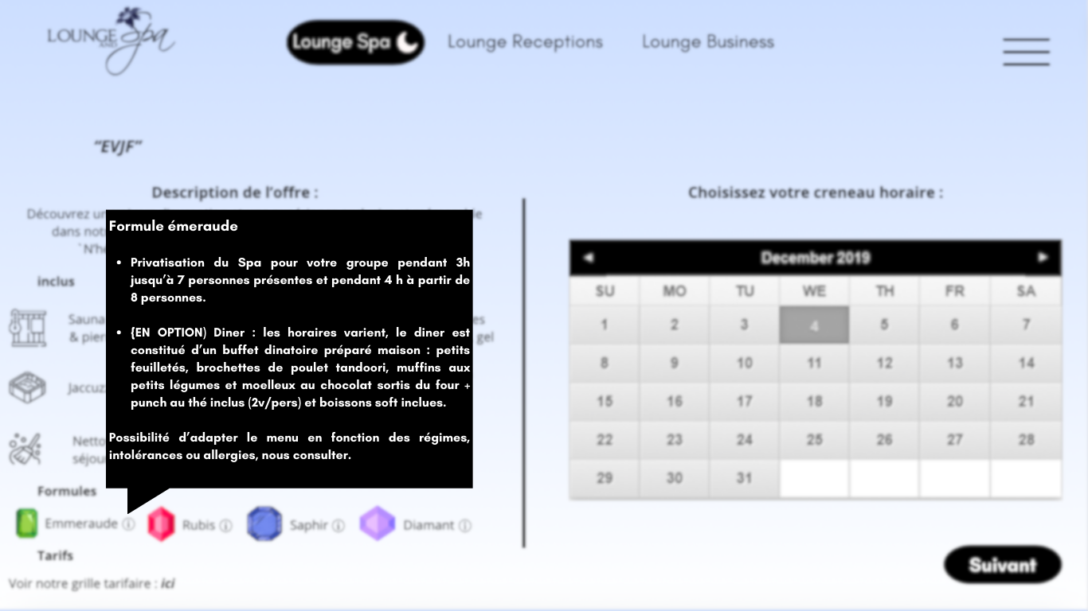

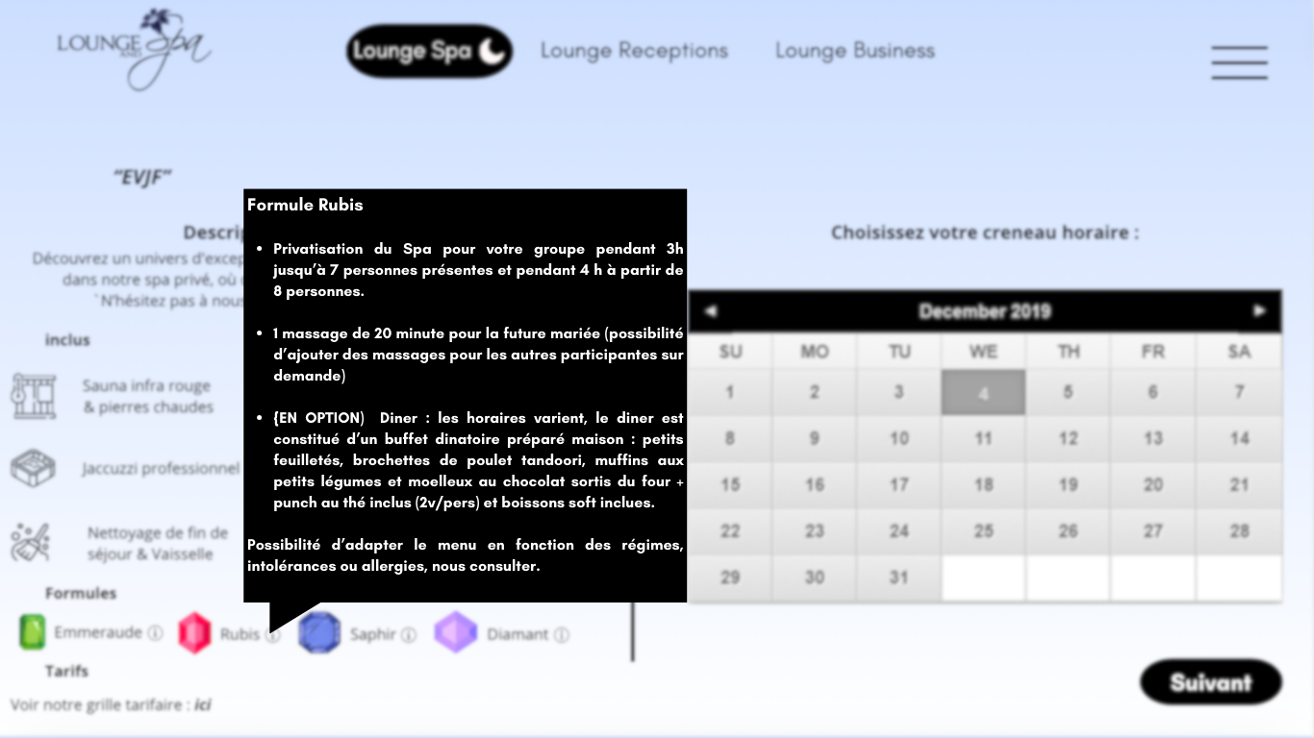

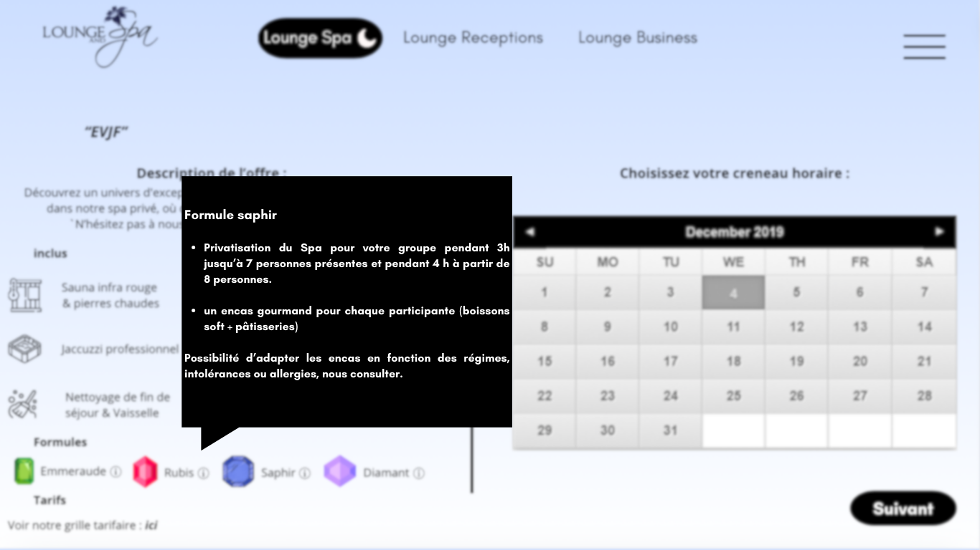

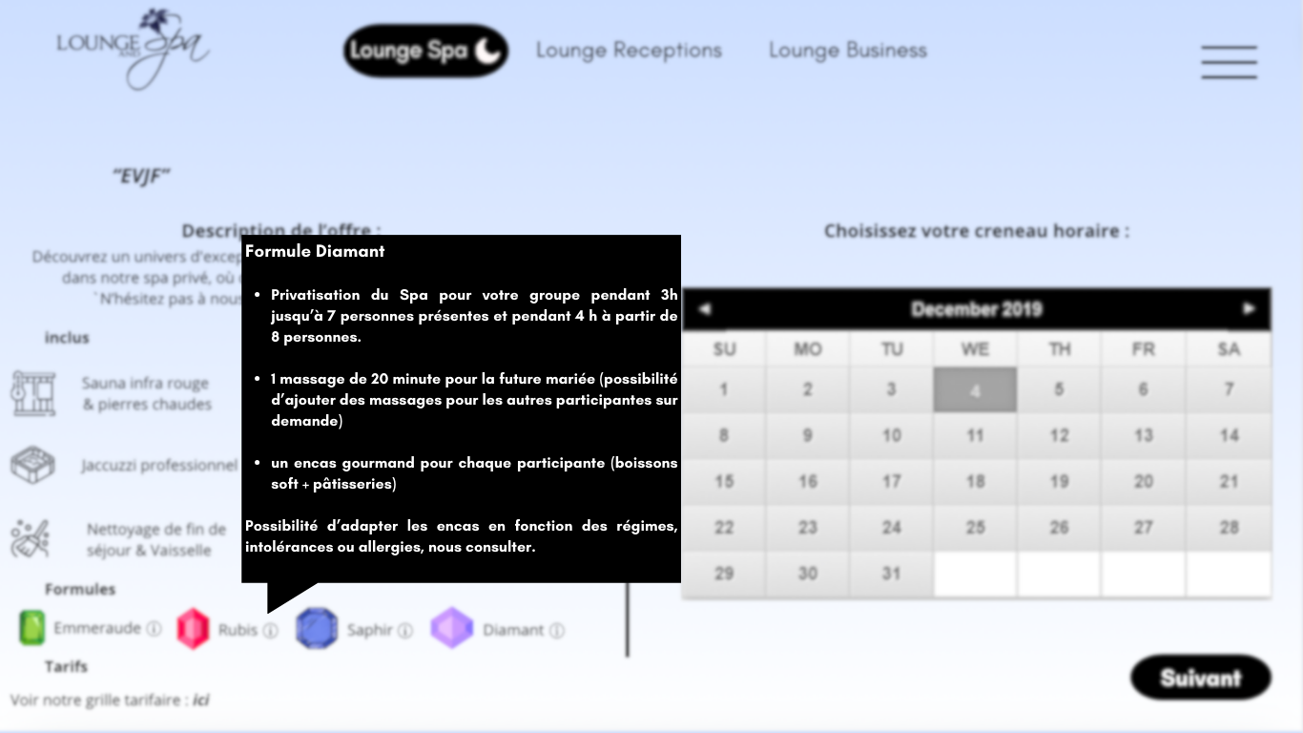

* When you hover over the small information points: more explanation appears and the rest of the screen blurs (apart from the offer concerned)
* When you click on “here” (price) > display of the brochure with prices in a new tab: https://www.loungespa.fr/wp-content/uploads/2022/11/Formule-EVJF.pdf

(improve the brochure a little?: make the logo and link clickable + clarify with bullet points what exactly each formula contains?)

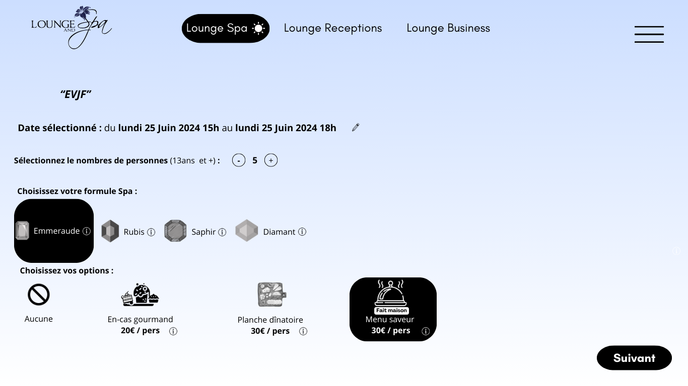

* + Add the option for additional hours next to dining options (allow selecting the number of hours with "+" and "-" like for the number of people).
  + Remove the "Saveur" menu option.
  + Replace "planche dinatoire" with "buffet dinatoire" (or a more prestigious synonym if available).
  + The pencil icon allows modifying dates and times;
* indicate "modify" when hovering.
  + When clicking the small "i" (info), redirect to <https://www.loungespa.fr/wp-content/uploads/2022/11/Formule-EVJF.pdf>
  + When clicking "Next," propose activity options for the entire Lounge Receptions section (find a better term than "activity options" if possible) and the accommodation section:
  + For activity options:
* Clicking on an option highlights it in white with a black selector, similar to other options.
* Directly show the price for the number of people previously selected (if it's 0 or 1, revert to the price per person).
* Allow selecting multiple activities and add a warning when clicking "Next": "Have you accounted for everyone?" (or something similar) + a specific warning if the number of people does not match (but allow validation if confirmed).
  + Validate activities and prices.
  + The small "i" (information) provides a description of the activities (description to be created).
  + Propose visuals (icons like for the other options) for each activity (once validated).
  + For accommodation options:
* Interface with the site "Les 2 Étangs" (see what's possible):
* Ideally, validate the availability.
* Validate the number of chalets and the type of chalet based on the number of people.
* Provide an alternative for groups larger than 5 people (see the screenshot), e.g., 1 chalet for 5 people + 1 mattress (not provided).
* Display the price for "Les 2 Étangs" (60€ per night during the week and 70€ on Friday and Saturday).
* "Les 2 Étangs + shuttle" = Price of one or more chalets at "Les 2 Étangs" based on the number of people + 10€/person (price to be validated).
  + Propose visuals (icons like for the other options) for each accommodation option.

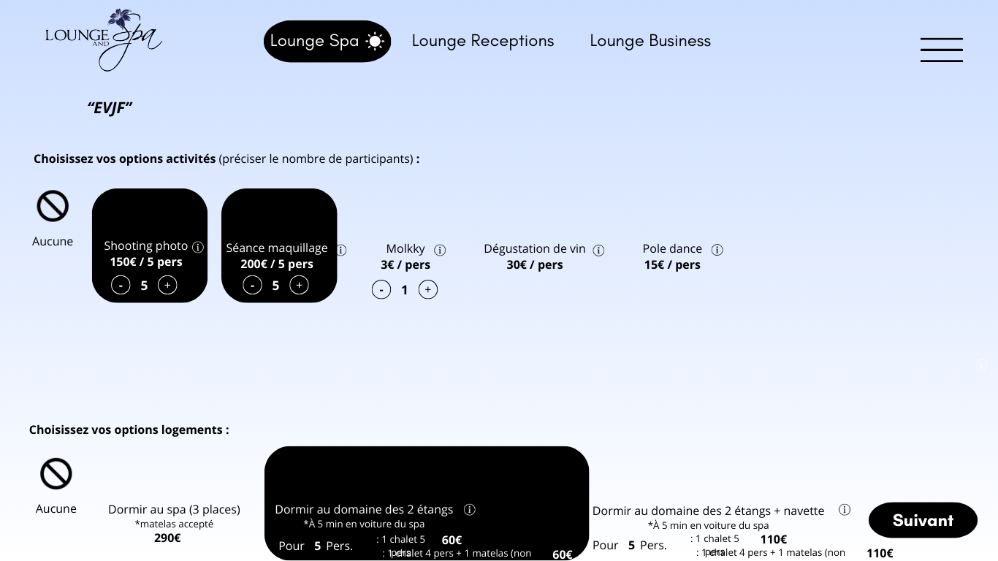

* + Activities:
* Add the option for Californian massages (include massage / Polynesian universe).
* Remove other activities (e.g., photo shoot, etc.).
  + For each option selection section: Include the total near the "Next" button. Update the price dynamically based on the selected options.
* Consider optimizing the visual layout of the options to avoid "lack of space" and ensure clarity.
  + When clicking "Next": Follow the same pattern with the payment screen, etc., as with the other offers.

### Name of the offer 2 : Birthdays:

**Homepage for Birthday Offers:**

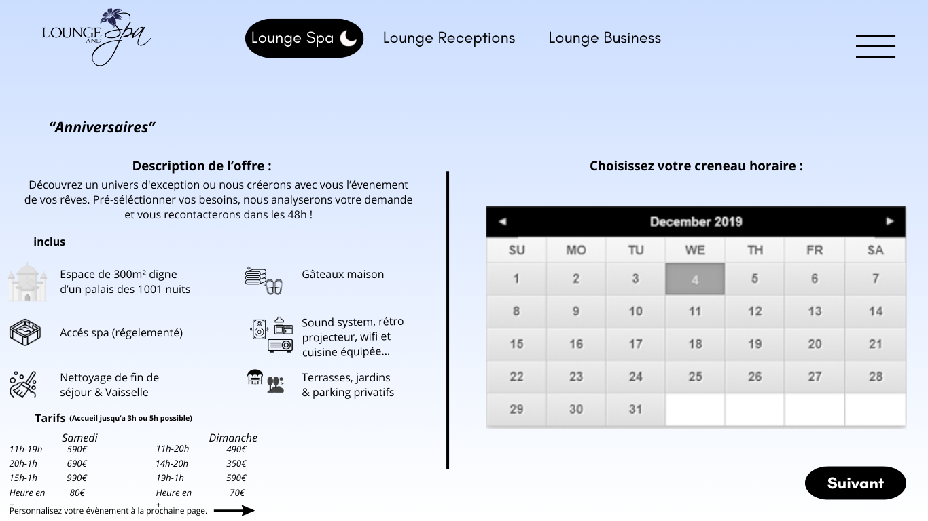

* + Adapt the icons and ensure their visual coherence (e.g., a palace icon is nice but not in grey).
  + Change the icon and content: replace "homemade cakes" with something else => define what is included and what should be highlighted.
  + Add a small 'i' icon for the sound system section and add three dots after "equipped kitchen."
* In the info section, add the following elements:
* You can prepare music playlists on CD, USB key, or streaming platforms (Deezer, Spotify...), Karaoke, wireless microphone. Dance floor, Bar, Cold room 1m3, Small kitchen pantry, Reception rooms, 25 seats, 9 standing tables (4 inside/5 outside).
  + Add a small 'i' icon for the terraces and pergola section:
* In the info section, indicate:
  + - * Terrace 50m²
      * Pergola 12m²
      * Enclosed parking
* Do not allow validation if the number of people is not specified!

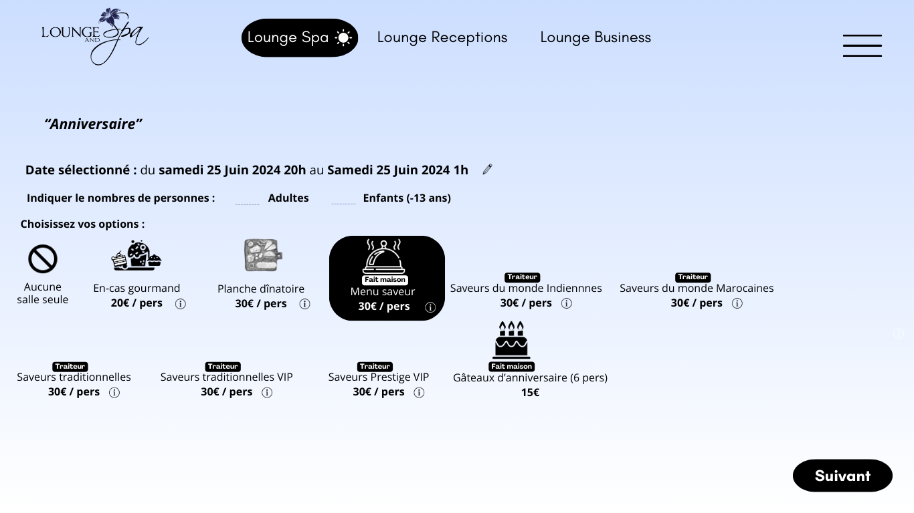

* For each small "i" (info):
* For snacks, "planche dinatoire," and "menu saveur": use the description from the website with photos (test how it looks if these elements are included in the small info pop-up).
* For the "traiteur" (catering) section, use inspiration from the sheets: [https://www.loungespa.fr/wp-content/uploads/2023/05/buffet-dinatoire-saveur-monde-sans-prix.pdf`](https://www.loungespa.fr/wp-content/uploads/2023/05/buffet-dinatoire-saveur-monde-sans-prix.pdf%60)
* Make sure to provide all details and add more photos for each dish (new photos will be taken if needed).

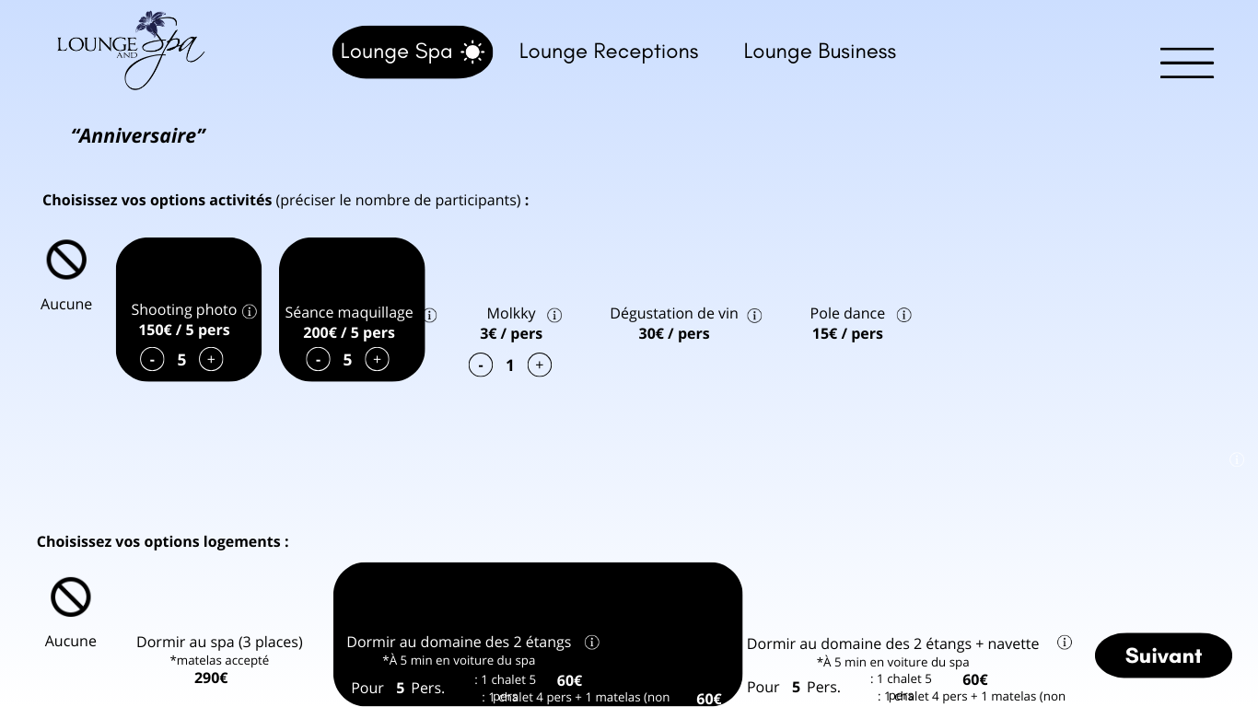

* Activity options to complete and validate.
* As for each part selection of options: include the total near the next button. Change the price with the selected options
* When clicking "Next," follow the same process with the payment screen, etc., as with the other offers.

### Name of the offer 3 : Wedding, engagement, wedding anniversary…

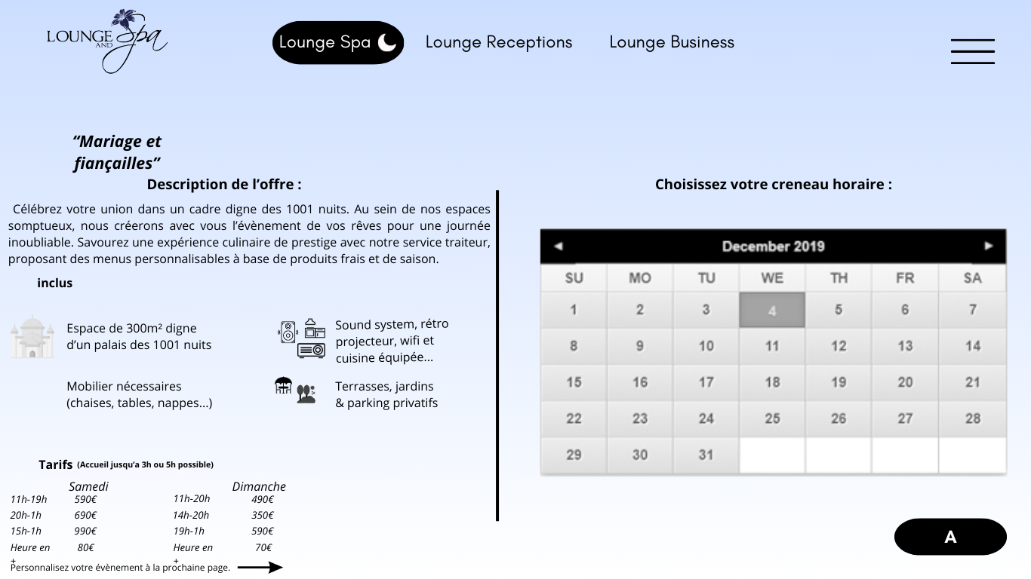

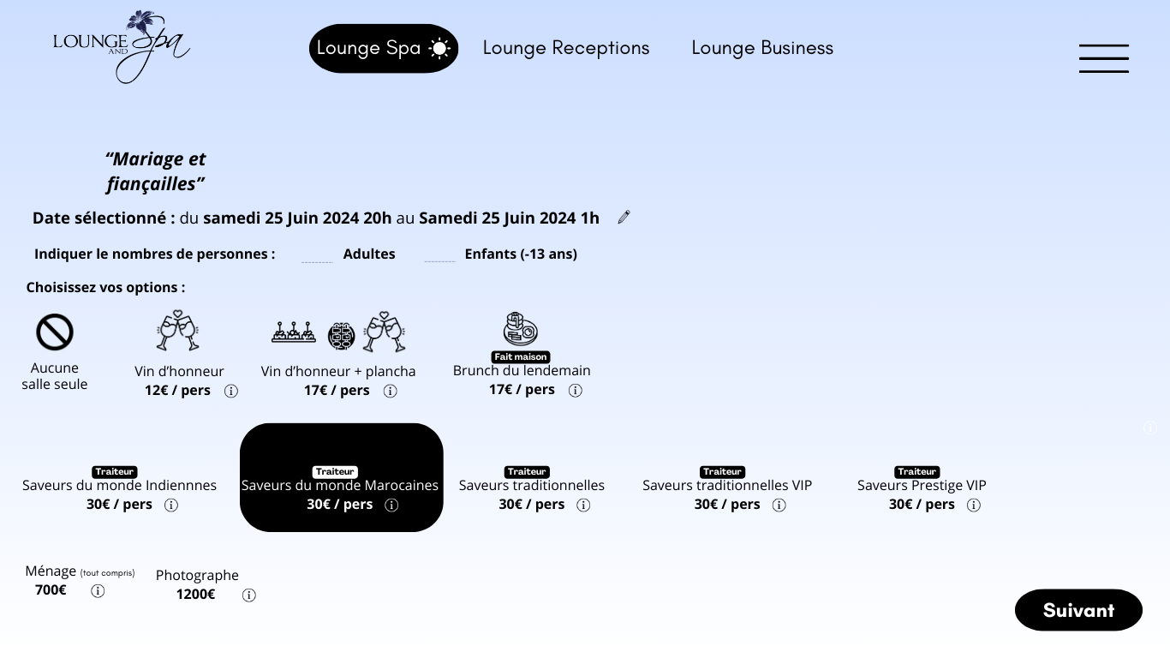

* For the brunch option: ensure that the client has selected the venue for the following noon! (not selectable otherwise)
* Add a caution message in the info section: selectable only if the venue is rented on Sunday noon.
* Add a warning message if the client attempts to select this option but has not selected the venue until Sunday morning.
* As with each section where options are selected: include the total near the "Next" button. Update the price based on the selected options.
* When clicking "Next": follow the same process with the payment screen, etc., as with the other offers.

### Name of the offer 4 : Weekend with Friends: All Inclusive

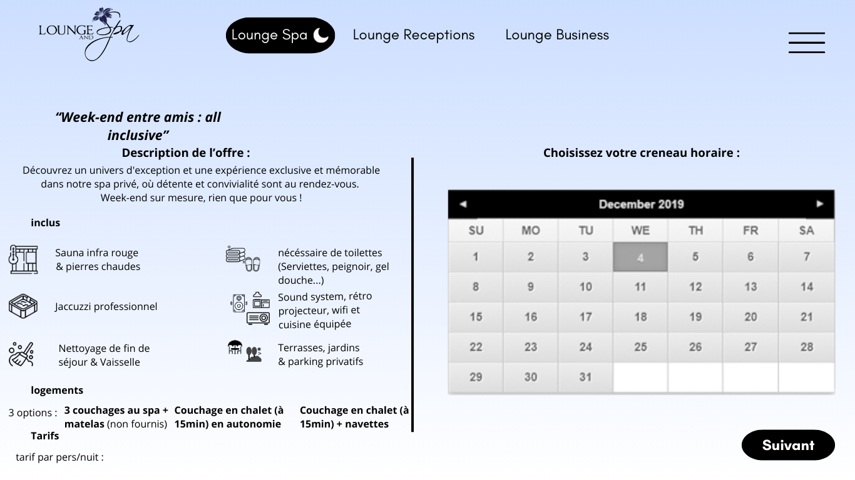

* Display the real-time rate for the 3 options based on the duration of the stay.

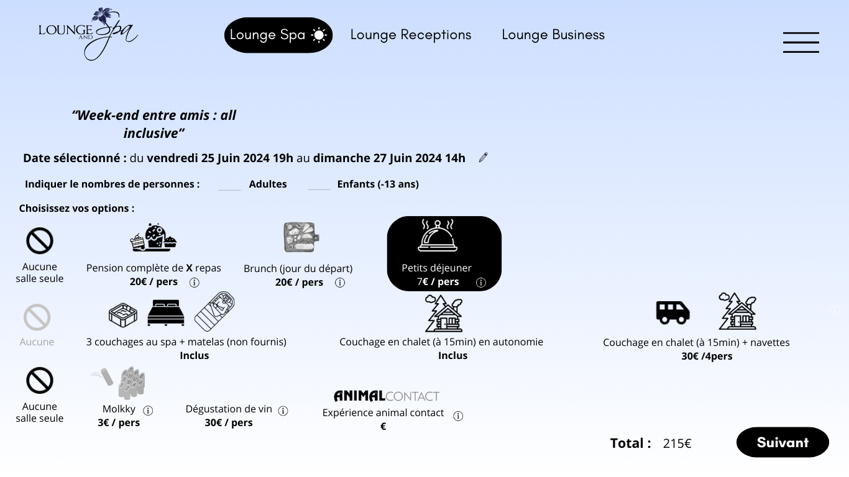

* Price to be defined: 2 options considered:
* Price per person per night indicated and calculated in real-time with the number of people + duration of stay.
* Or price indicated in real-time based on the choice of stay duration + number of people, and which evolves according to the selected options.
* Update the full board price based on the number of meals on-site (see selected dates and times).
* As with each section where options are selected: include the total near the "Next" button. Update the price based on the selected options.

### Name of the offer 5 : Customized Reception

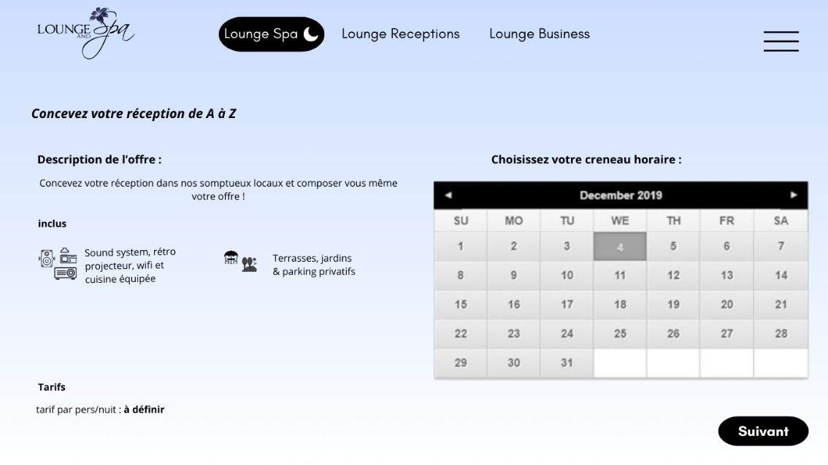

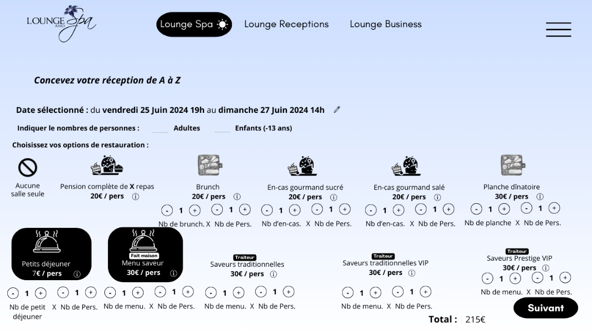

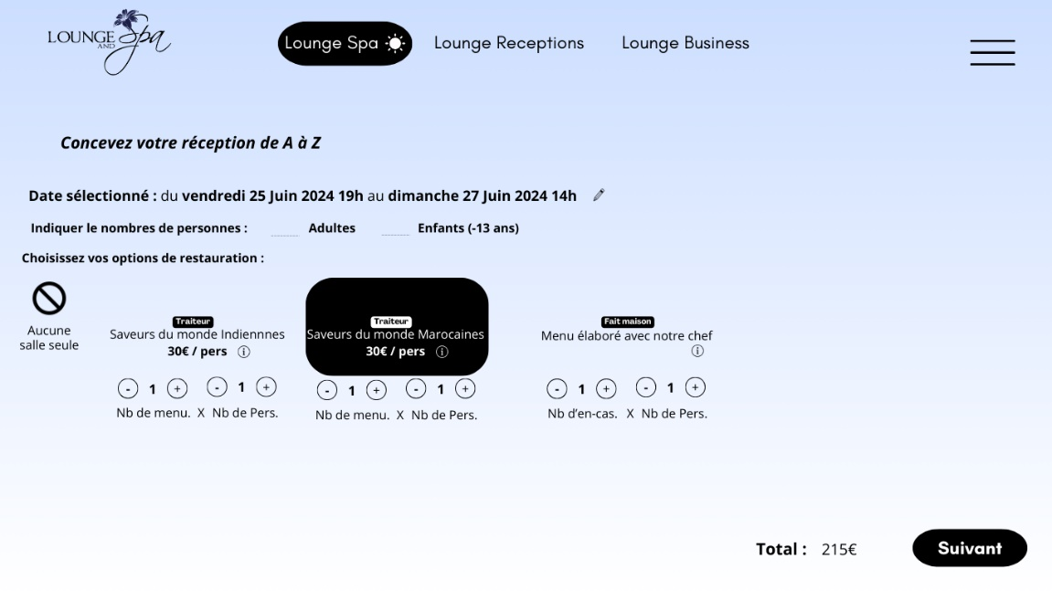

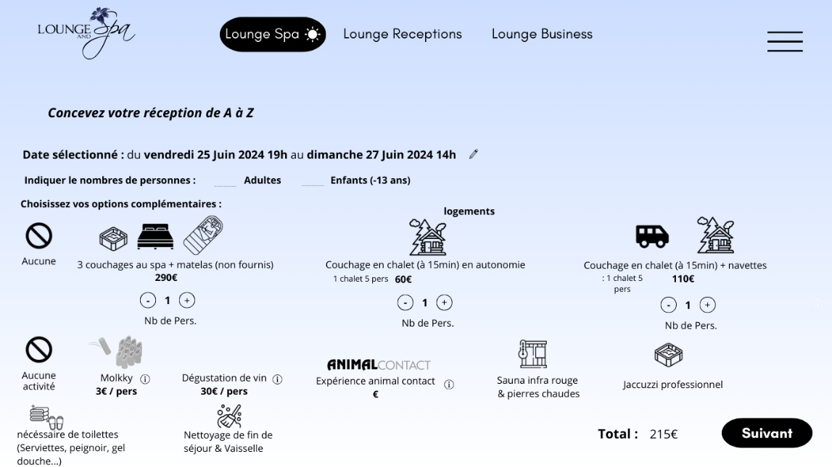

• Coordinate the availability of beds with the 2 ponds site

• Alert message if there are not enough places on these dates at the 2 ponds (and encourage you to contact us to find a solution)

# Lounge Business

## Lounge Business Offer:

**Homepage for Lounge Business Offers**

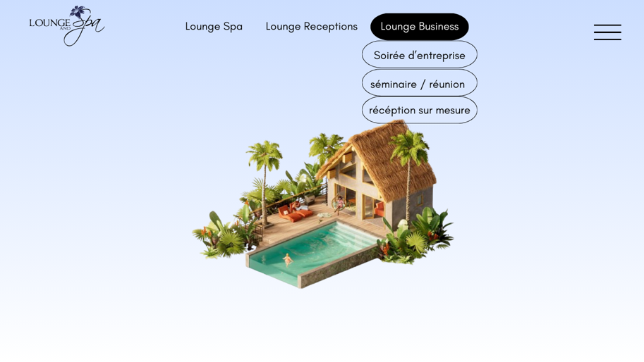

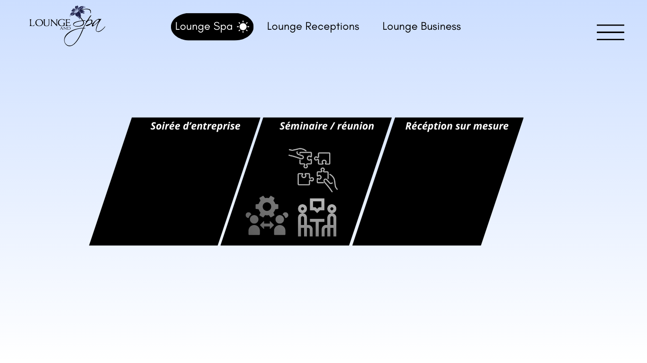

* Change the icons and find more relevant (and more aesthetically pleasing) ones.
* Create 2 different offers (add a black square + icons):

### Name of the offer 1 : Corporate Event

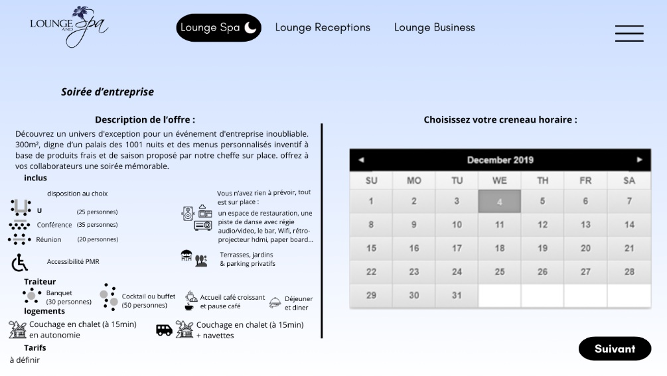

* Price to be specified

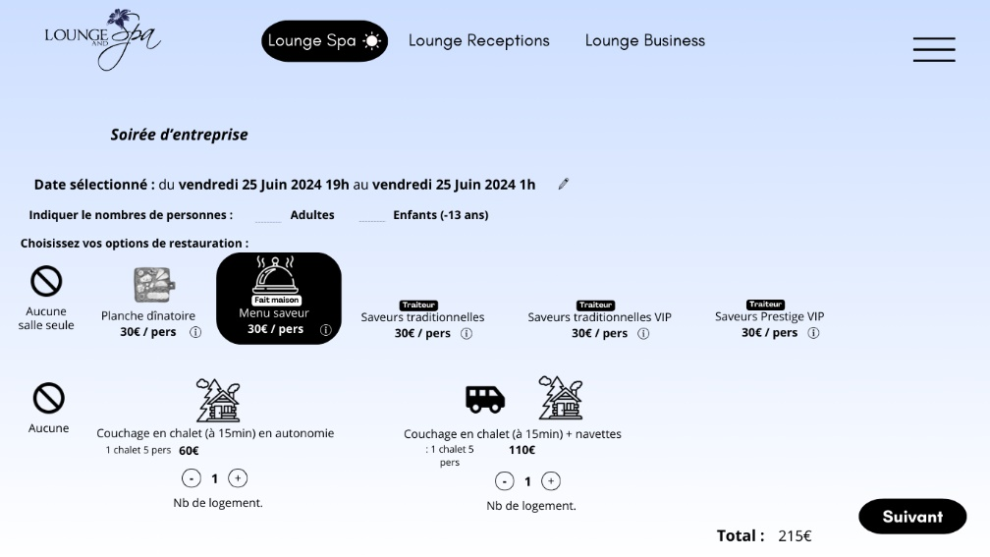

* Coordinate the availability of beds with the 2 ponds site
* Alert message if there are not enough places on these dates at the 2 ponds (and encourage you to contact us to find a solution)

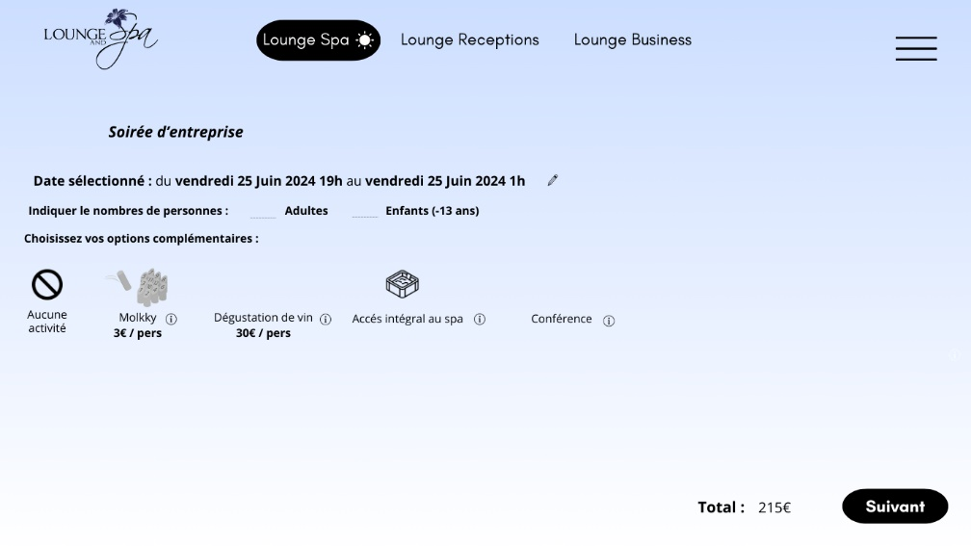

### Name of the offer 2 : Seminar

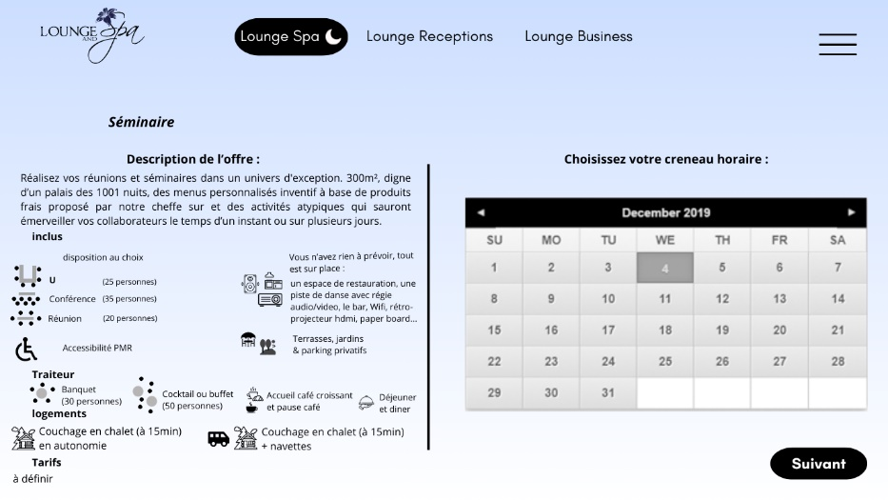

* Accommodation: Perhaps add bedding in a hotel (with our partner)

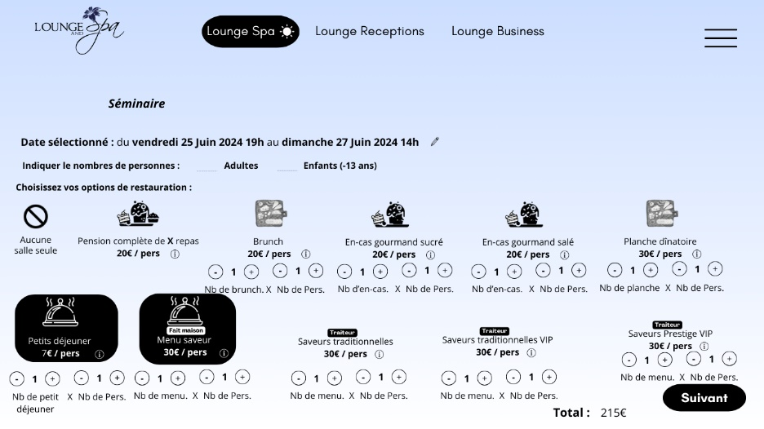

* The idea is to allow the selection of different types of meals depending on the number of days and the possibility of changing

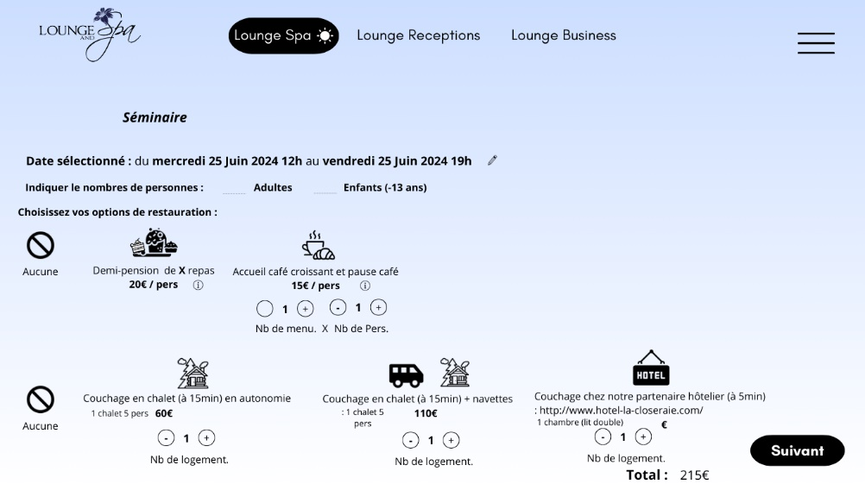

• Coordinate the availability of beds with the 2 ponds site

• Alert message if there are not enough places on these dates at the 2 ponds (and encourage you to contact us to find a solution)

• See what is possible with the hotel site

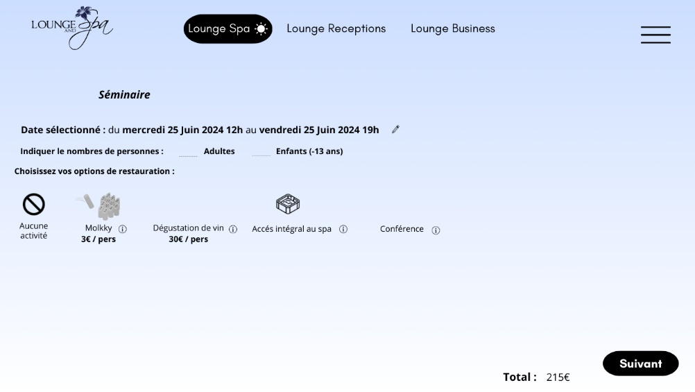

• Activities to add

### Name of the offer 3 : Meeting

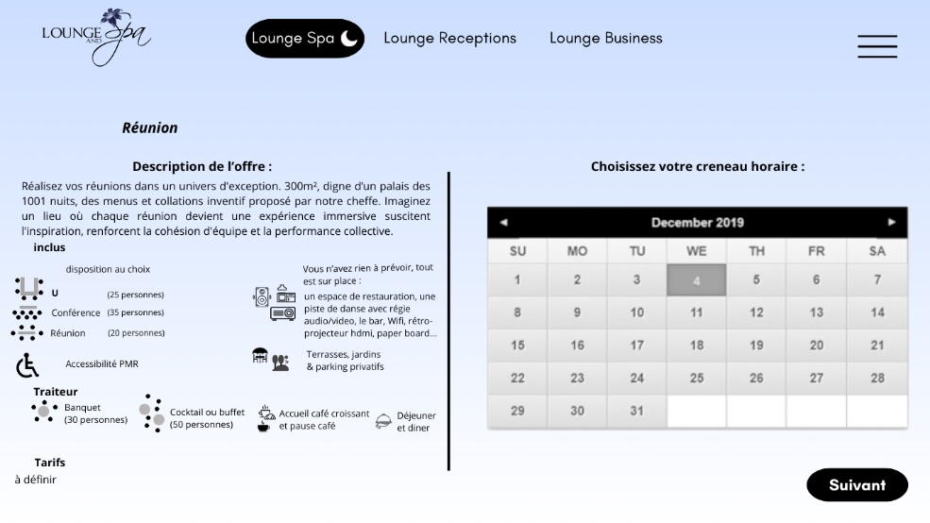

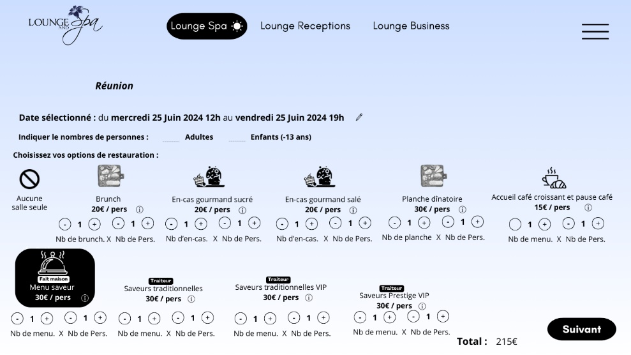

### Name of the offer 4 : Custom Reception

Set the same parameters and follow the screen

# Videos and Position on the website

Home

* Image type Airbnb: best areas of the spa
* Discover our spaces:
  + 1 virtual tour: in progress (use the link that I sent you on what’sapp)
  + Real photos of our spaces (I’ll give them to you when you will be there)
  + 3D plan (need to be built once the construction work in the spa will be finished)

Lounge & Spa:

* 1 Airbnb-style video

Lounge Reception

* 1 Airbnb-style video

Lounge Business

* 1 Airbnb-style video